School Name
Yearly Examination
2015
Year 10

Mathematics Course
General Instructions  - Reading time: 5 minutes  - Working time: 2 hours  - There will be a short break between Section 1 and Section 2  - Write using black or blue pen  - You may use a pencil to draw or complete diagrams  - Attempt ALL questions  - Approved calculators may be used in Section 2.  - A Ruler and Geometric Instruments will be needed for all parts of the test.  - Write your Name and Teacher’s Name in the spaces provided.  - A formula Sheet is on the reverse of this page and can be detached and used in all sections of the test. | Total Marks – 100  Section 1  Non Calculator Section.  25 marks  Time allowed for this section is 30 minutes.  Write all answers in the spaces provided.  Section 2  Time allowed for this section is 1 hour and 30 minutes.  Part A  Multiple Choice Section.  Mark your answers on the separate answer sheet at the end of the examination.  50 marks  Part B  Longer Answer Section.  Write all answers in the spaces provided.  25 marks

Formula Sheet
Pythagoras’ Theorem
c = hypotenuse
a and b are the shorter sides

Circumference of a circle
d = diameter

Area of a circle
r = radius

Area of a parallelogram
b = base
h = perpendicular height

Area of a rhombus or kite
x and y are the diagonals

Area of a trapezium
h = perpendicular height
a and b are the parallel sides

Volume of a prism
A = area of base
h = perpendicular height

Volume of a pyramid
A = area of base
h = perpendicular height

Volume of a cylinder
r = radius
h = perpendicular height

Volume of a cone

Volume of a sphere
Surface Area of a Cylinder

Surface Area of Cone
r = radius
l = slant height

Surface Area of a sphere

Trigonometric formulae for a triangle ABC.

Sine Rule

Cosine Rule
or
Area of a triangle
Simple interest
P = Principal
R = interest rate per time period as a decimal
T = number of time periods

Compound Interest
A = Final amount to which the investment grows
P = Principal
r = interest rate per compounding period as a decimal
n = number of compounding periods
Depreciation
SV = Salvage Value to which the initial value falls
IV = Initial Value
r = depreciation rate per compounding period as a decimal
n = number of compounding periods

Gradient of a line
and are points on the line
m = gradient

Midpoint of a line segment

Length of a line segment
Equation of a line
or
b = y intercept

School Name
Yearly Examination
Year 10
Mathematics Course
2015

Class/Teacher ______________________

Name______________________

Section 1

25 marks
Time allowed for this section is 30 minutes

Answer Questions 1–25 in the spaces provided.

Calculators are NOT to be used in this section.

There will be a short break between Section 1 and Section 2.

Section 1 Non Calculator Section
 | Write all working and answers in the spaces provided on this test paper.
1. | Write a decimal which is equivalent to 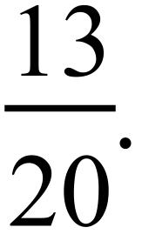  ……………………………………………………………………………………………....  ……………………………………………………………………………………………….
2. | Find 32% of $125.  ……………………………………………………………………………………………....  ……………………………………………………………………………………………….
3. | Samantha is paid at a wage rate of $24.00 per hour. What would she earn for working a 40 hour week?  ……………………………………………………………………………………………....  ……………………………………………………………………………………………….
4. | 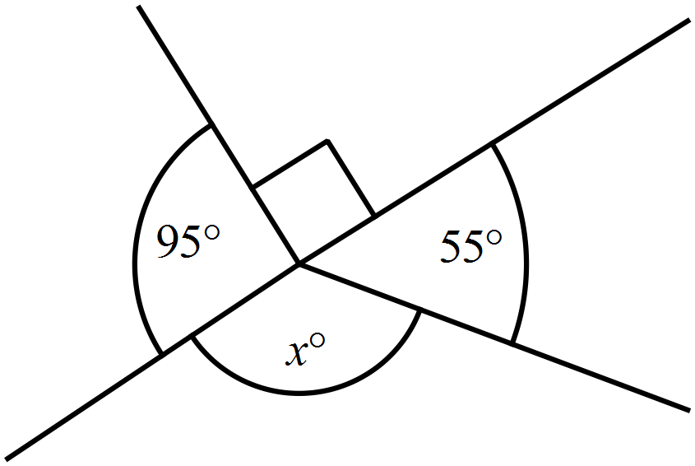What is the value of 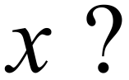  ………………………………………………  ……………………………………………....  ………………………………………………  ……………………………………………….
5. | 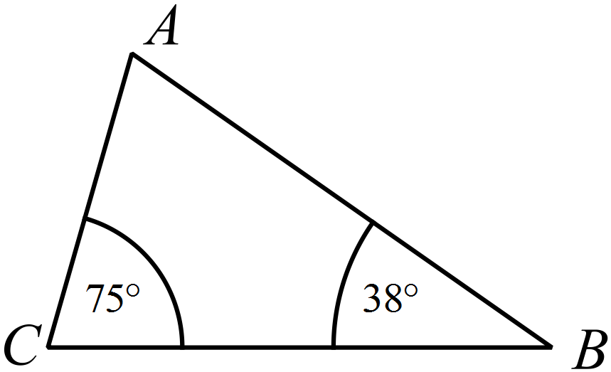What is the size of   ………………………………………………  ……………………………………………....  ………………………………………………  ……………………………………………….
6. |   Rob packs 200 thumb drives which each have a mass of 24 grams into a carton which has a mass of 1.8 kg. What is the mass of the fully packed carton? (Answer in kilograms.)  `  ……………………………………………………………………………………………....  ……………………………………………………………………………………………….
7. | 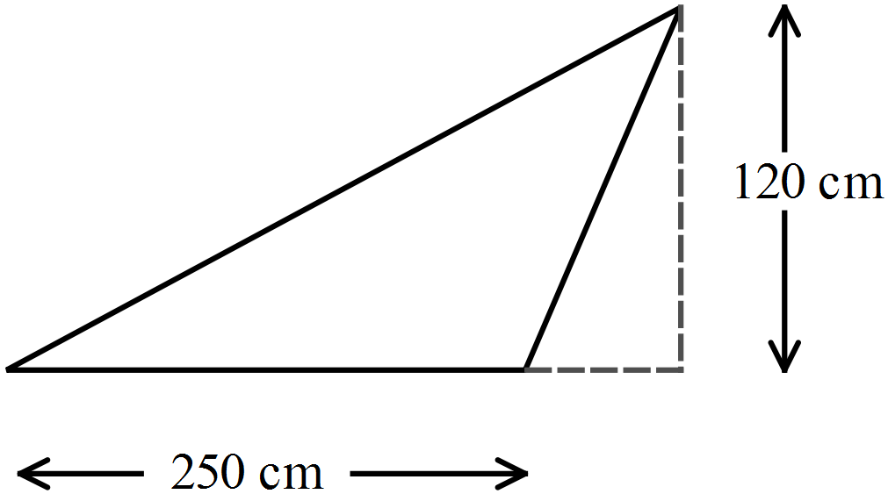What is the area of this triangle?  ………………………………………………  ……………………………………………....  ………………………………………………  ……………………………………………….
8. | 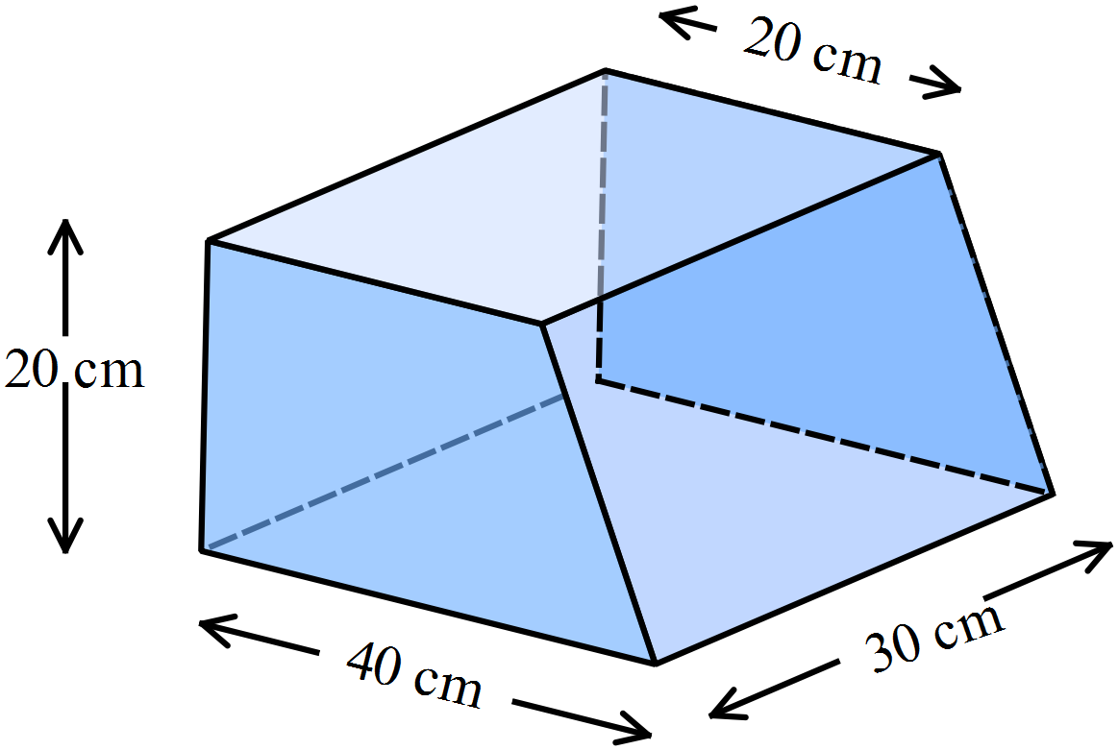What is the volume of this solid?  ………………………………………………  ……………………………………………....  ………………………………………………  ……………………………………………….
9. | 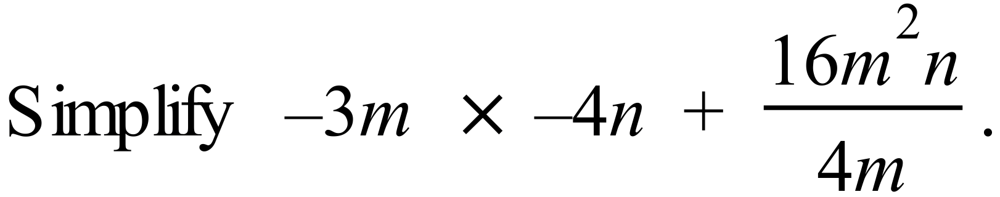  ……………………………………………………………………………………………....  ……………………………………………………………………………………………….
10. | ……………………………………………………………………………………………....  ……………………………………………………………………………………………….
11. | 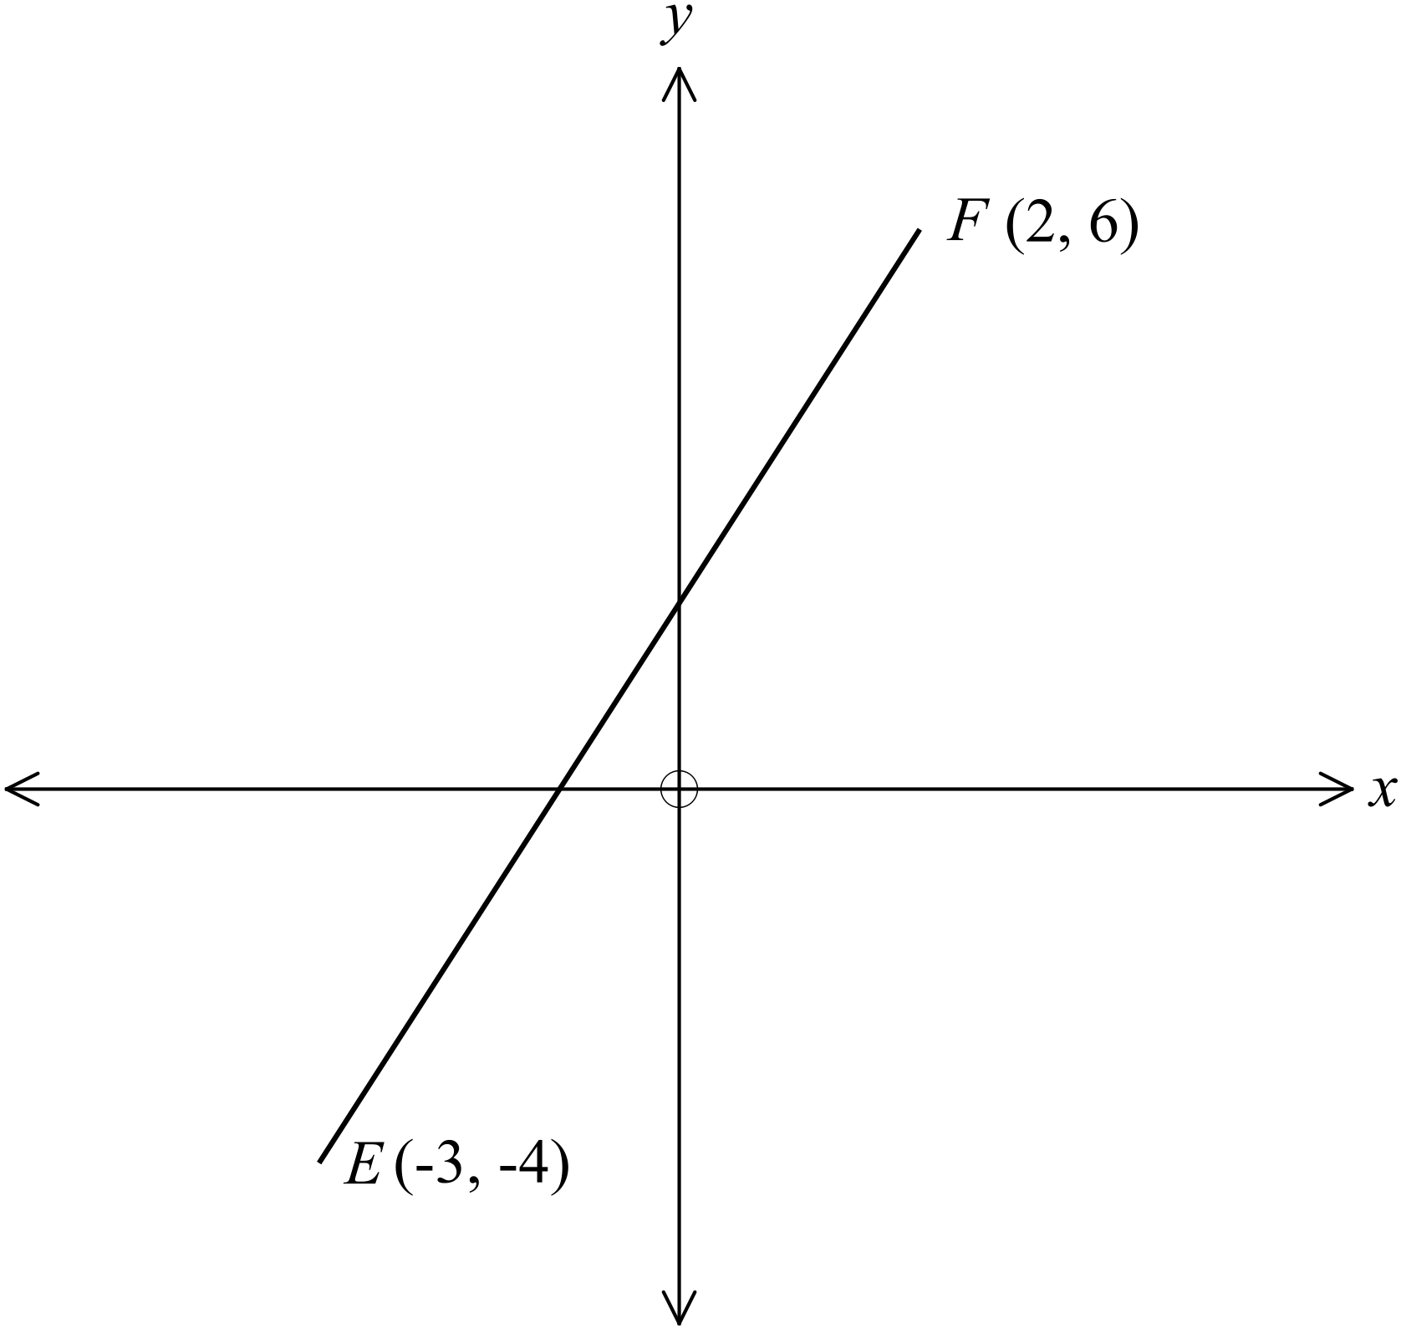What is the gradient of the interval 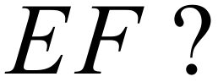  ………………………………………………  ……………………………………………....  ………………………………………………  ……………………………………………….
12. | 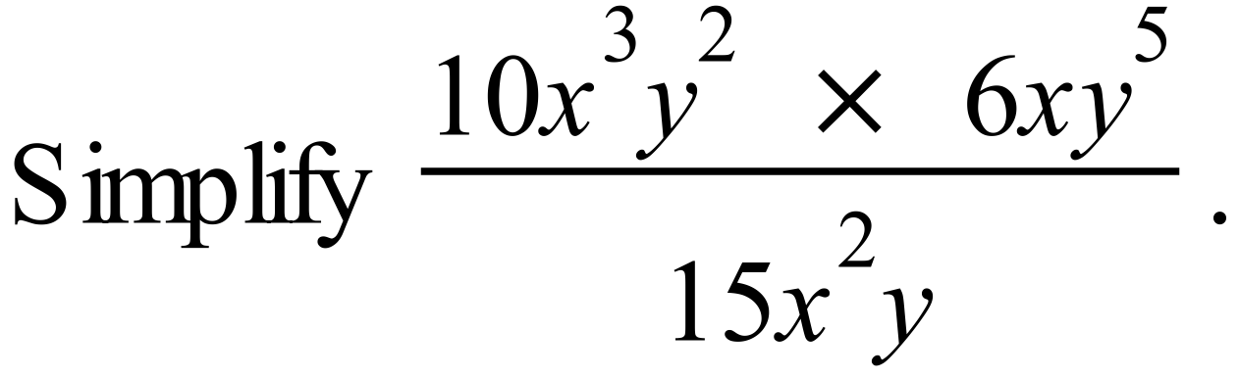  ……………………………………………………………………………………………....  ……………………………………………………………………………………………….
13. | Solve: 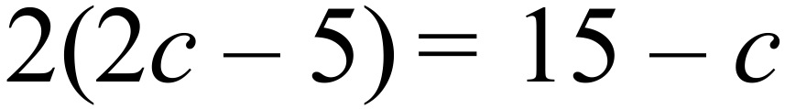.  ……………………………………………………………………………………………....  ……………………………………………………………………………………………….
Questions 14 and 15 refer to the dot plot below.

The plot shows the scores by 20 golfers over a full round of a course.
 |  |  |  |  |  | ⃝
 |  |  |  |  |  | ⃝ | ⃝
 |  |  |  | ⃝ | ⃝ | ⃝ | ⃝
 |  |  | ⃝ | ⃝ | ⃝ | ⃝ | ⃝
 | ⃝ | ⃝ | ⃝ | ⃝ | ⃝ | ⃝ | ⃝ | ⃝
 | 46 | 47 | 48 | 49 | 50 | 51 | 52 | 53

14. | The par for the course is a score of 50.  What percentage of the golfers scored below 50?  ……………………………………………………………………………………………....  ……………………………………………………………………………………………….
15. | What was the median score for the 20 golfers?  ……………………………………………………………………………………………....  ……………………………………………………………………………………………….
16. | Simplify the ratio 12.5 : 50.  ……………………………………………………………………………………………....  ……………………………………………………………………………………………….
17. | 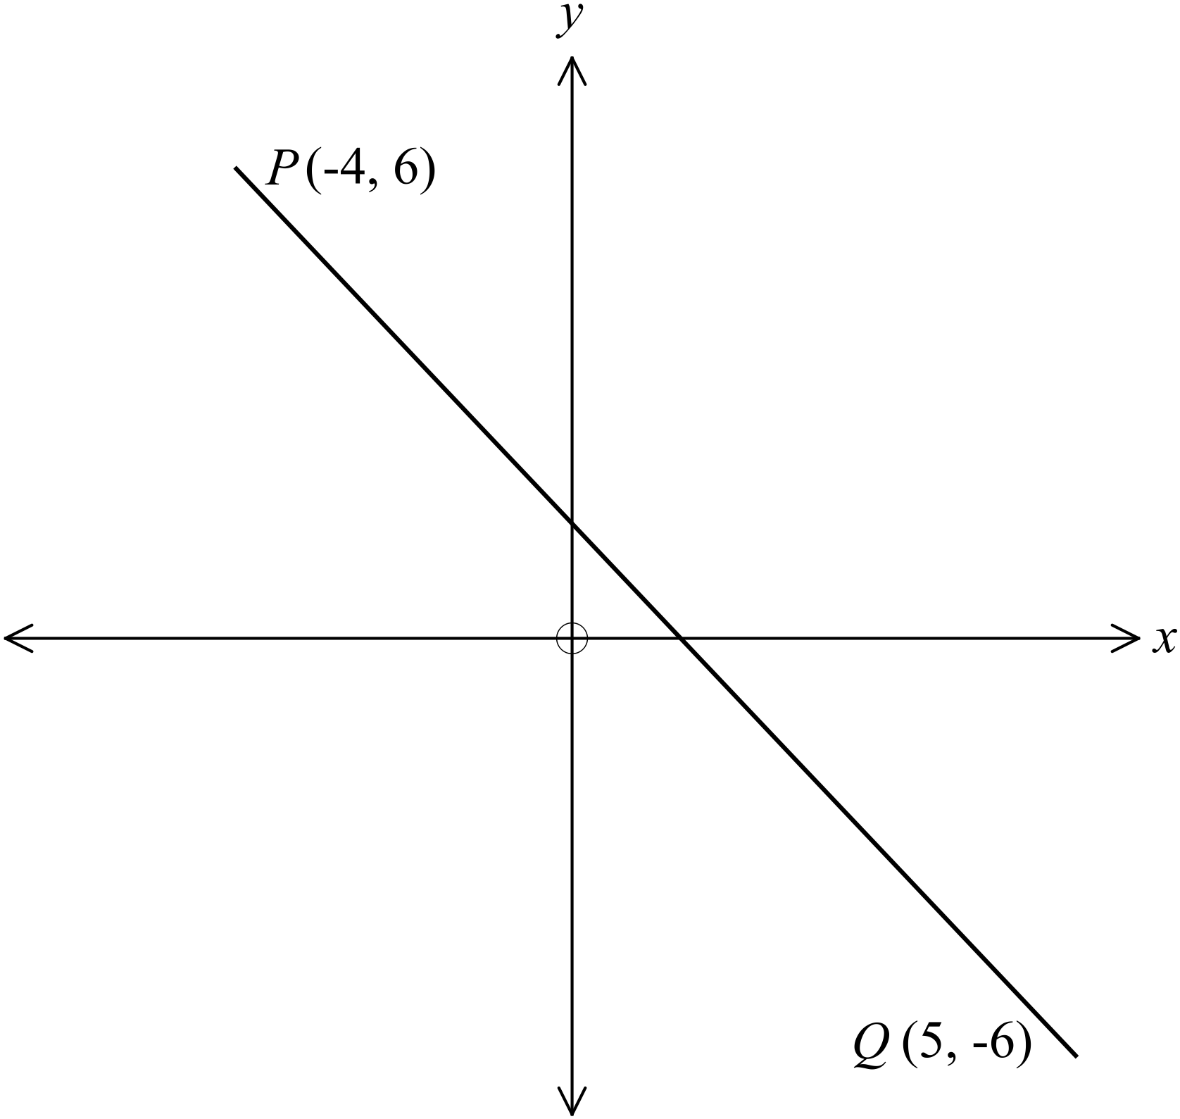What is the length of the interval 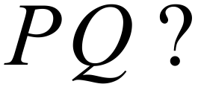  ………………………………………………  ……………………………………………....  ………………………………………………  ……………………………………………….
18. | 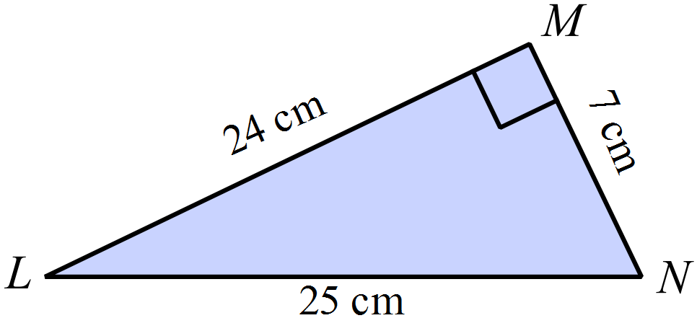What is the value of  in the right triangle shown?  ………………………………………………  ……………………………………………....  ………………………………………………  ……………………………………………….
19. | 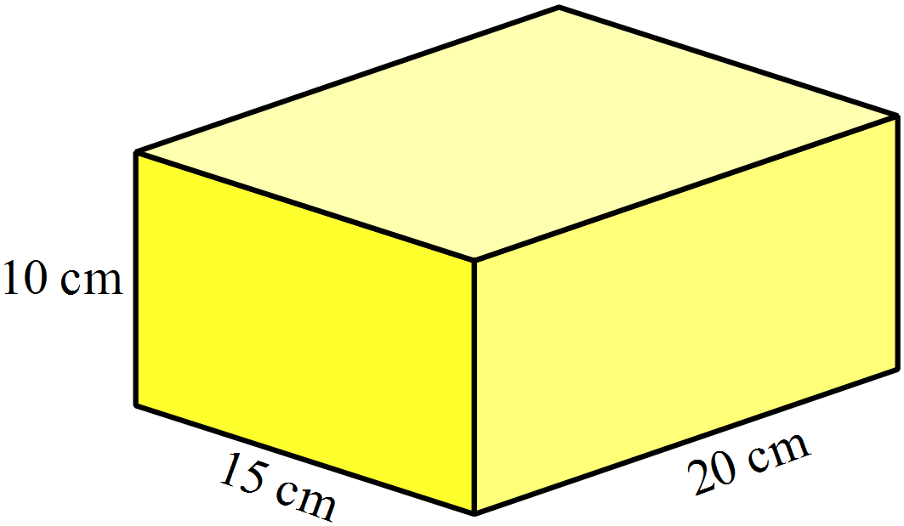Find the surface area of the rectangular prism shown.  ………………………………………………  ……………………………………………....  ………………………………………………  ……………………………………………….
20. | 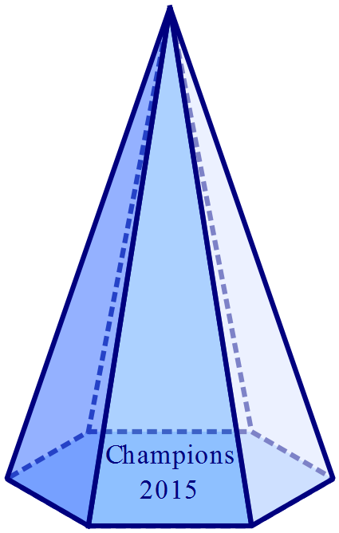A glass pyramid is used as a trophy for a netball competition.  It has a hexagonal base with an area of 30cm² and a perpendicular height of 12 cm.  What volume of glass is used in the trophy?  ……………………………………………....  ………………………………………………  ……………………………………………….
21. | Use geometric instruments to draw a 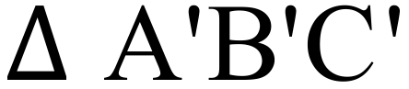 which is congruent to  below, but which has been rotated through 180º about the point D.  The point C’ has been drawn for you.  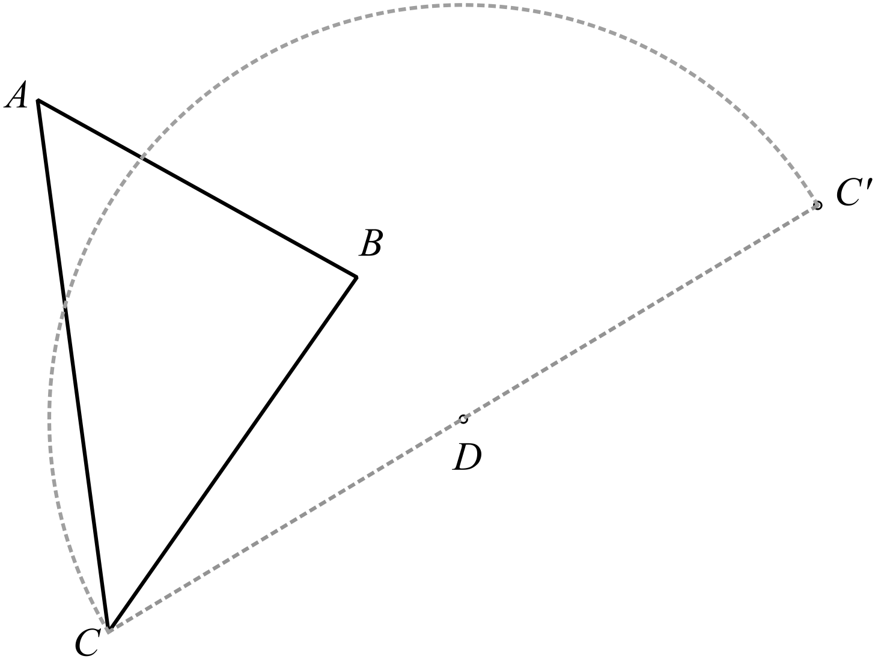Leave all of your construction lines on the diagram.
22. | There are some black, some white and some patterned counters on a table, as shown.  If one counter is picked up at random from the table, which colours are equally likely to be picked up?  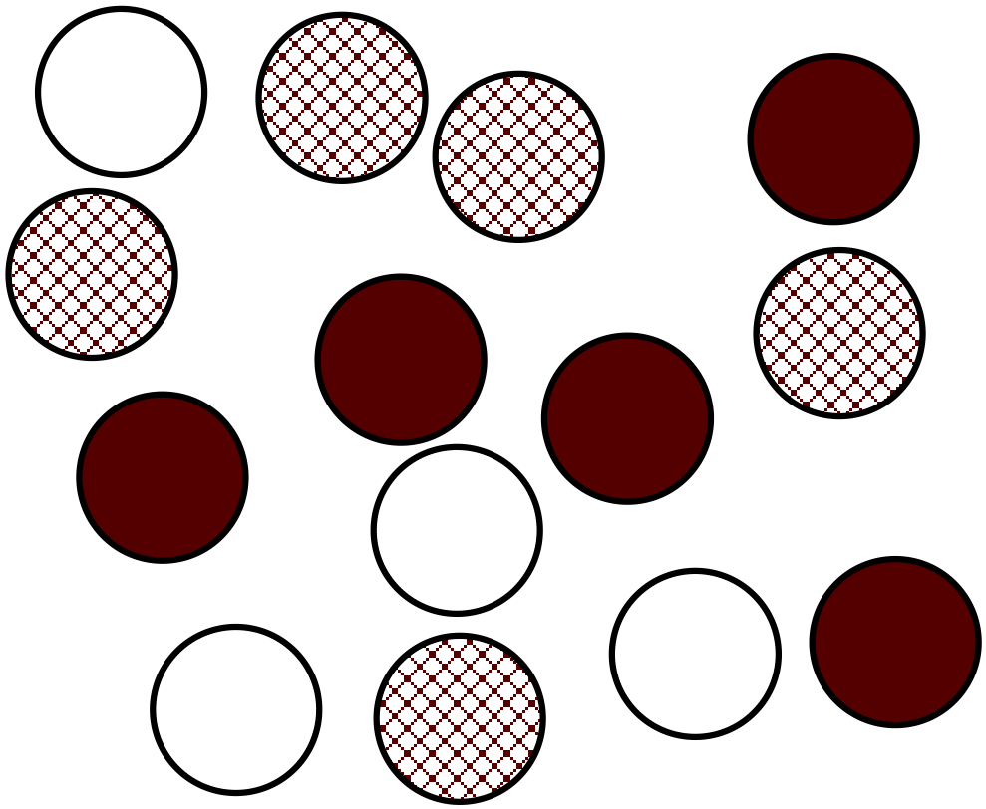  ………………………………………………  ……………………………………………....  ………………………………………………  ……………………………………………….
23. | 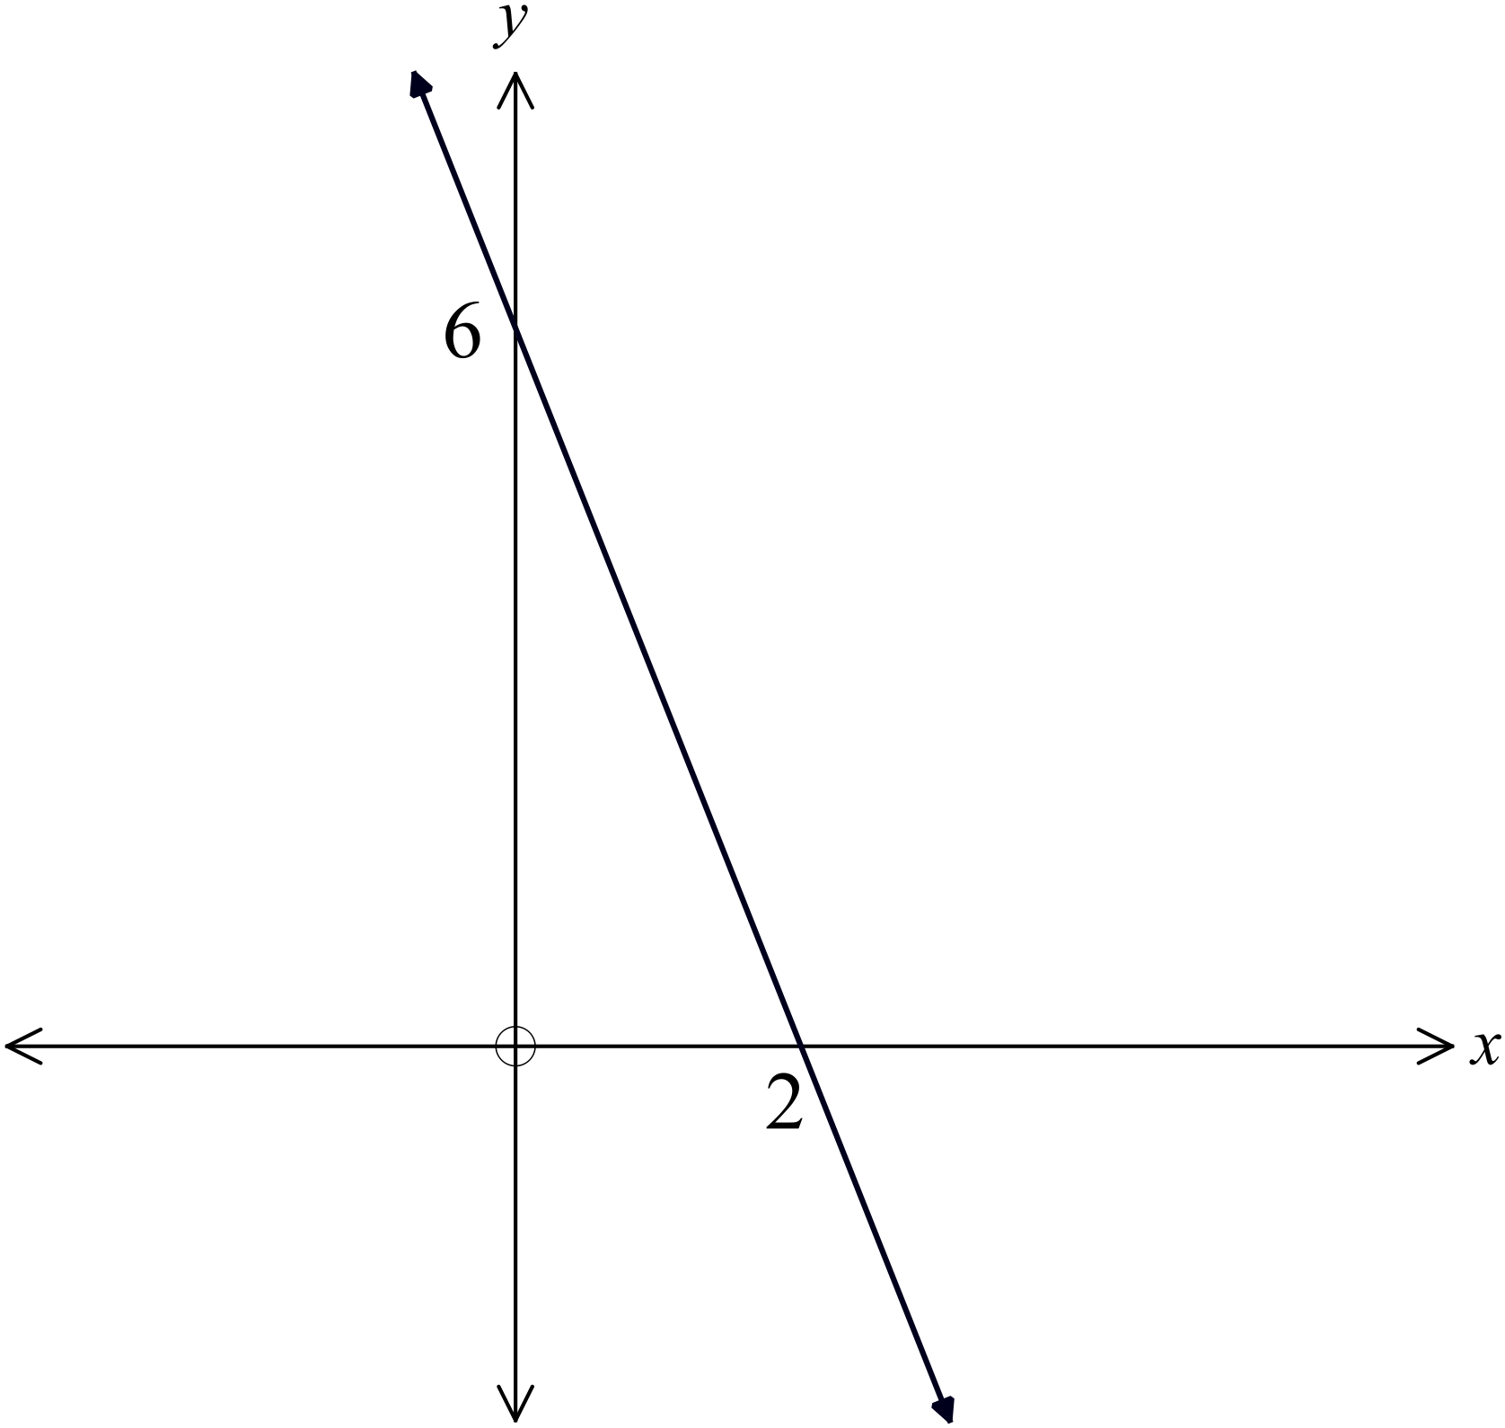What is the equation of the line drawn on the set of axes shown?  ………………………………………………  ……………………………………………....  ………………………………………………  ……………………………………………….
24. | Use the table below to draw a sketch of the curve 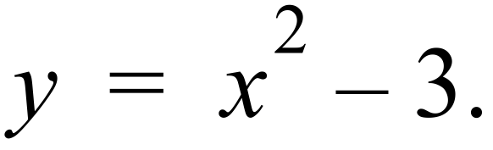  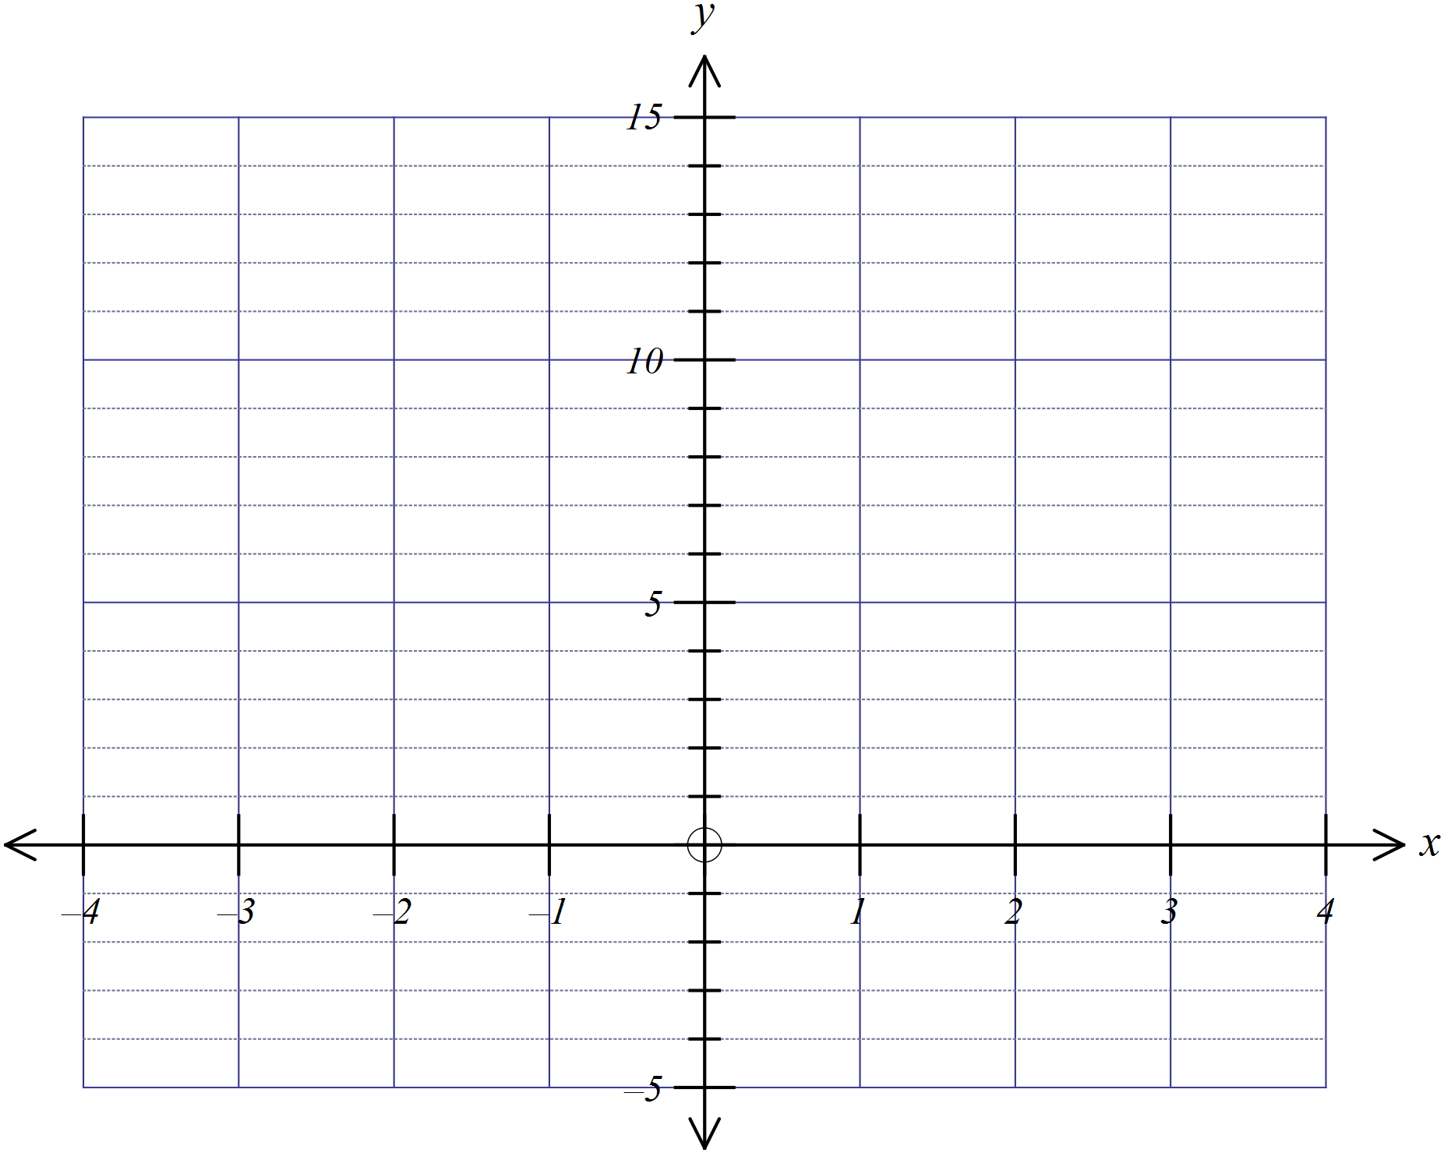
  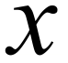 | -4 | -3 | -2 | -1 | 0 | 1 | 2 | 3 | 4
  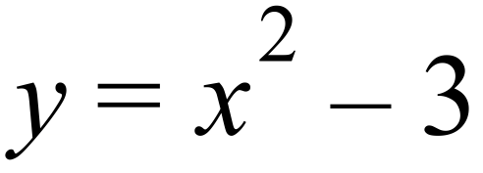 | 13 | 6 | 1 | -2 | -3 | -2 | 1 | 6 | 13
25. | Trapezium A is similar to trapezium B.  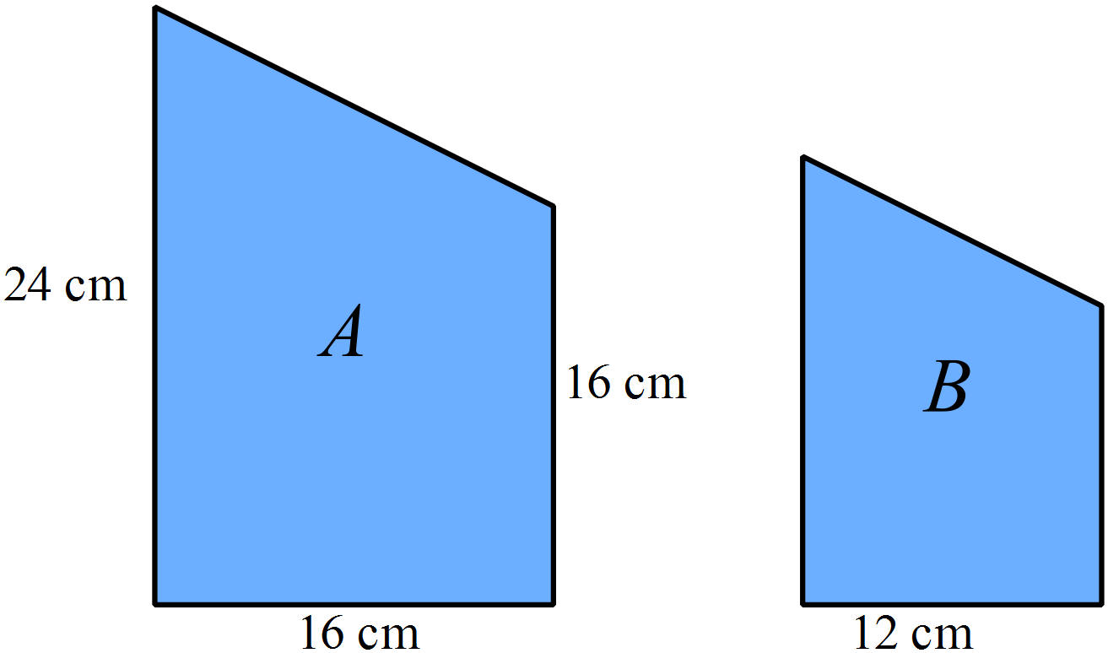  What is the area of trapezium B?  ….…………………………………………………………………………………………....  ……………………………………………………………………………………………….  ….…………………………………………………………………………………………....  ……………………………………………………………………………………………….
 | End of Section 1

School Name
Yearly Examination
Year 10
Mathematics Course
2015

Section 2

75 marks
Time allowed for this section is
1 hour and 30 minutes

This section has TWO parts

Part A – Fifty multiple-choice questions worth 1 mark each.
Mark your answers on the separate answer sheet provided at the end of the examination.
Part B – Longer answer questions worth a total of 25 marks.
Write all answers and working in the spaces provided on this examination paper.

Calculators may be used in this section.

Do not commence Section 2 until you are instructed to do so.

Use the multiple choice answer sheet at the end of the paper to record your answers.
Completely shade the bubble corresponding to the correct answer for each question.

Which of these is the same as 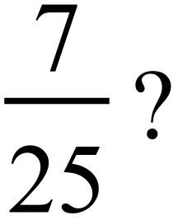

A. 7% B. 27% C. 28% D. 35%
What is the value of 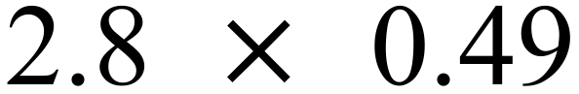, correct to 2 decimal places?

A. 1.3 B. 1.36 C. 1.37 D. 1.38
Which of these gives the highest annual income?

A. $840 per week.
B. $1650 per fortnight.
C. $3580 per month.
D. $43 500 per annum.
Mitchell is paid a retainer of $456 per week plus a 2.5% commission on his sales.
What would he be paid in a week where his sales were $24 000?

A. $600 B. $1056 C. $1068 D. $6456
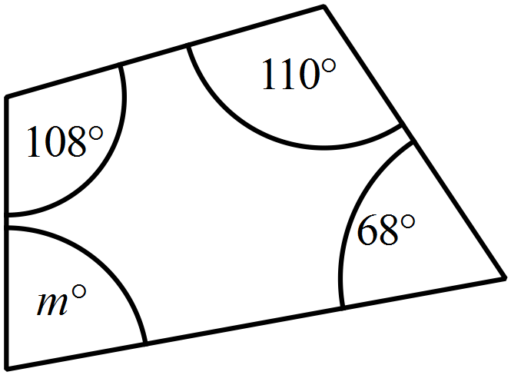What is the value of m?

A. 74
B. 106
C. 108
D. 110
A farm paddock has an area of 2.6 hectares.
What is its area in square metres?

A. 26 m² B. 260 m² C. 2600 m² D. 26 000 m²
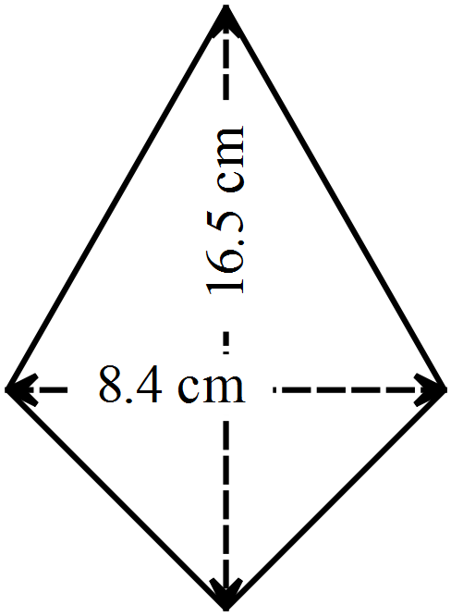What is the area of the quadrilateral shown?

A. 34.65 cm²
B. 49.8 cm²
C. 69.3 cm²
D. 138.6 cm²

A. 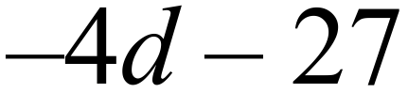 B. 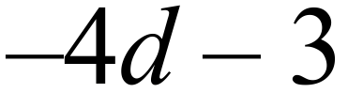 C. 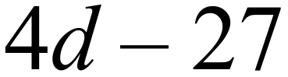 D. 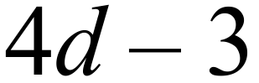
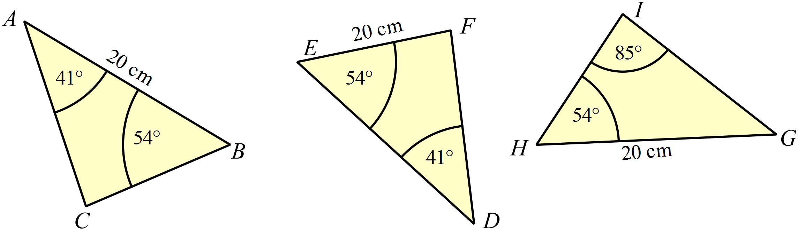

Which statement is true?
A.
B. 
C.
D. All of the above are true.
Expand and simplify 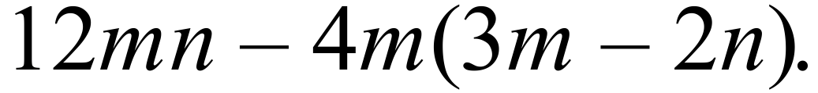

A. 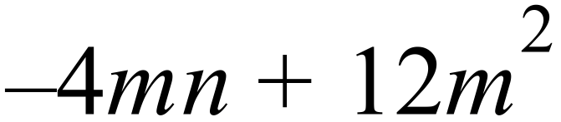 B. 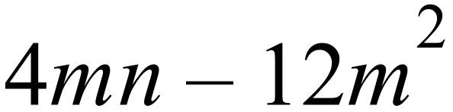 C. 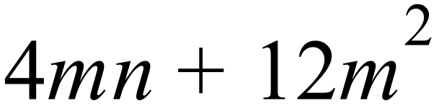 D. 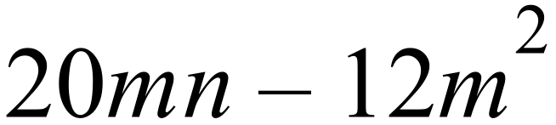
Scientists used historical data to estimate the number of kangaroos in the Severn Valley at 20 year intervals from 1800 to 2000.
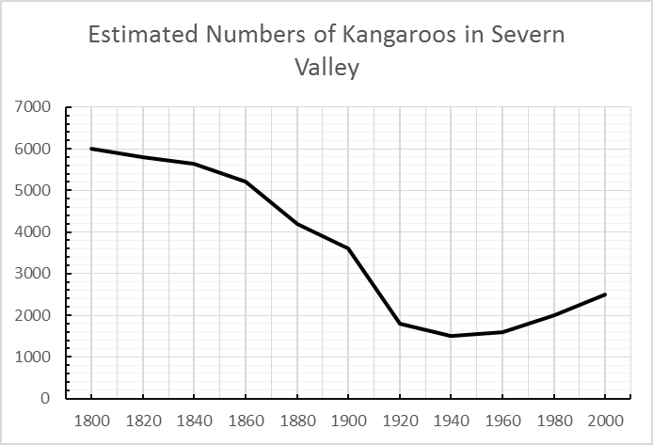
Between which years was the greatest change in the numbers recorded?
A. 1840 and 1860
B. 1860 and 1880
C. 1880 and 1900
D. 1900 and 1920
What is the midpoint of the interval joining A(–4, 6) and B(–10, –8).

A. (–7, –7) B. (–7, –1) C. (–3, –7) D. (–3, –1)
Simplify 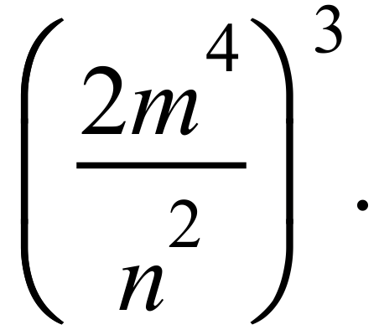

A. 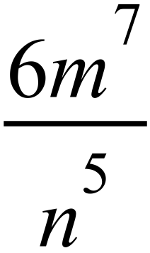 B. 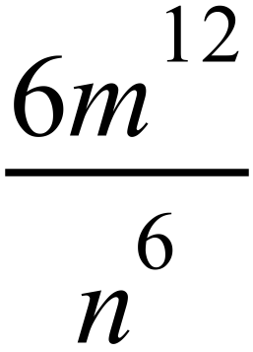 C. 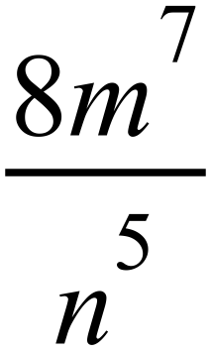 D. 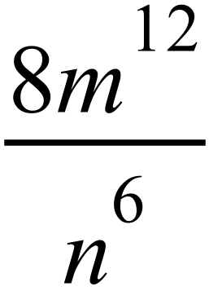
Solve the equation 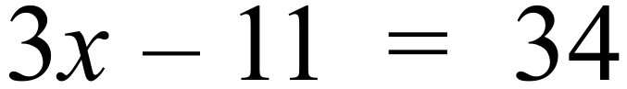

A. 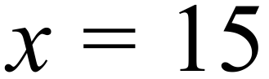 B. 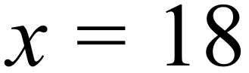 C. 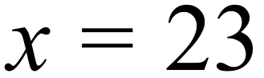 D. 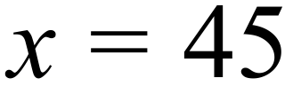
Lleyton’s training time to playing time is in the ratio 7 : 5.
He spent 28 hours training in a week.
How many hours did he spend playing in that week?

A. 20 B. 28 C. 39.2 D. 48
Questions 41 and 42 refer to the following.
The column graph shows the results of a survey of 80 people on the number of forebears they had still living.
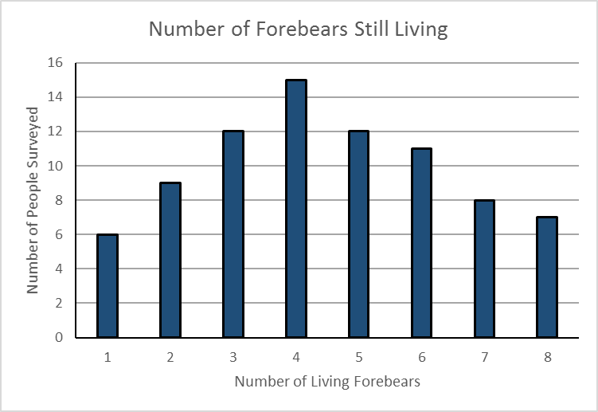
What percentage of those surveyed had more than 4 forebears living?

A. 35.0% B. 47.5% C. 52.5% D. 65.0%
What was the mean number of forebears (correct to 1 decimal place)?

A. 4.0 B. 4.2 C. 4.4 D. 4.5
What is the value of x, correct to 1 decimal place?
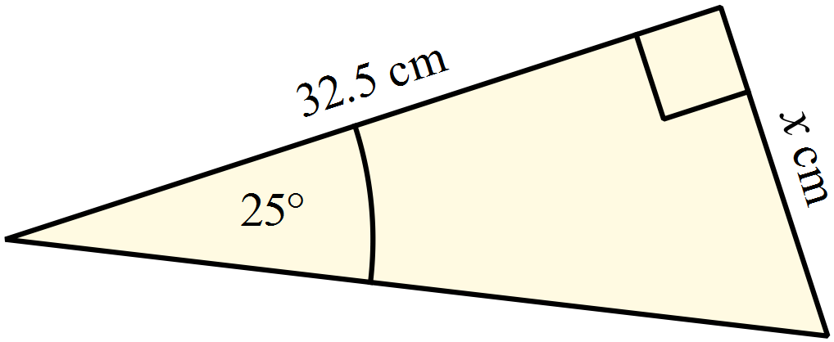
A. 13.7 cm
B. 15.2 cm
C. 29.5 cm
D. 69.7 cm
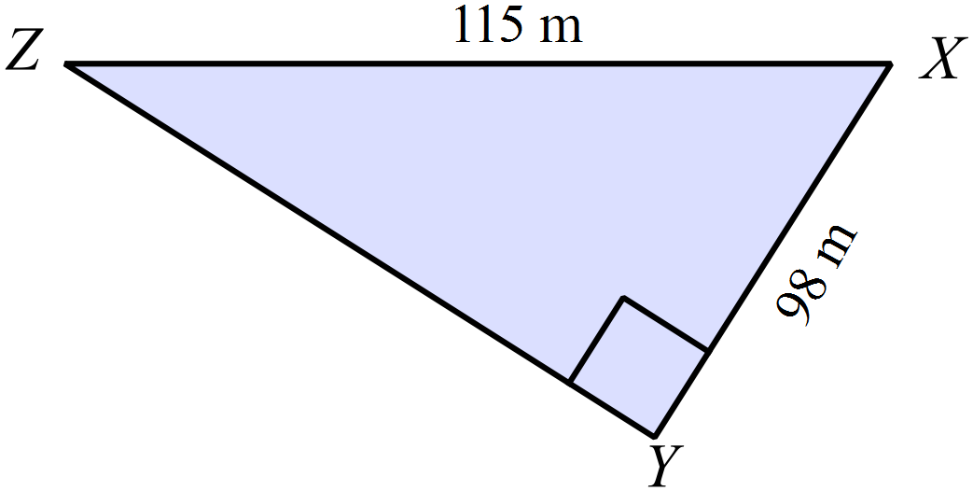What is the size of 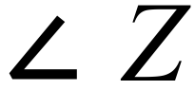 , to the nearest degree?

A. 32º
B. 40º
C. 50º
D. 58º
Jonas invests $8500 in an account that pays 4% p.a. compounding annually.
What is the value of the investment after 3 years?

A. $520.00 B. $9520.00 C. $9561.34 D. $9943.80
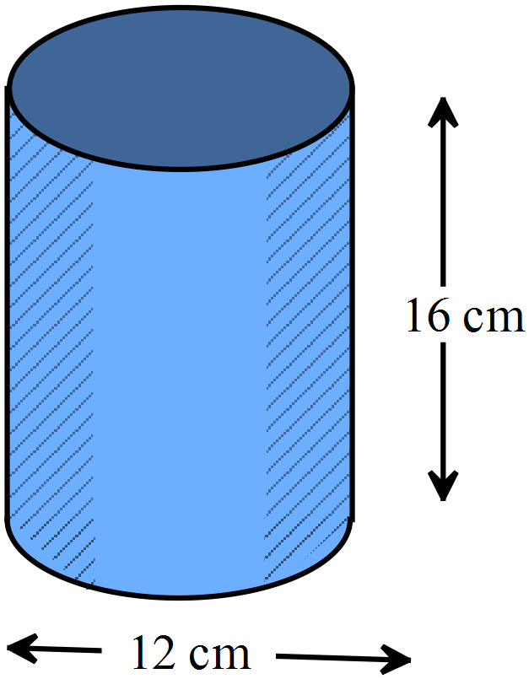A metal soup can has the dimensions shown.
What are of metal is needed to make the can?

A. 226.6 cm²
B. 603.2 cm²
C. 716.3 cm²
D. 829.4 cm²

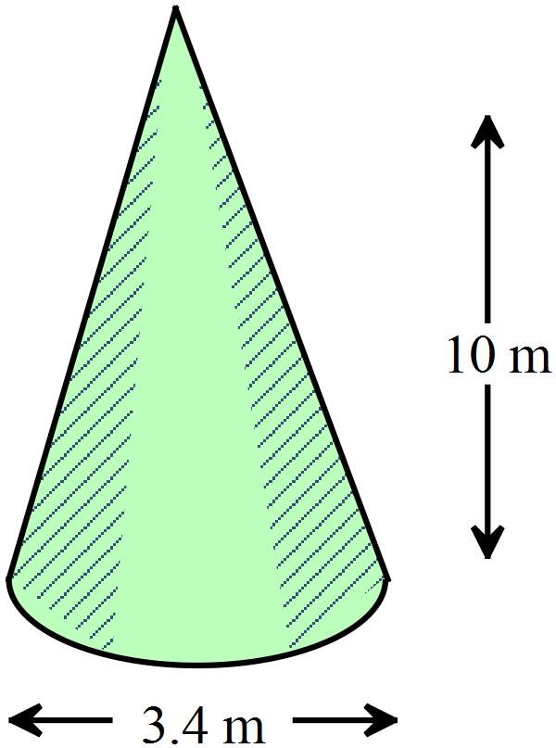What is the volume of this cone?

A. 30.3 cm³
B. 36.3 cm³
C. 60.5 cm³
D. 90.8 cm³

In a Year 10 class, all members support one of the local football teams.
The number who support each are shown in the table.
Team | Number of Supporters
Penguins | 8
Petrels | 5
Albatrosses | 7
Skuas | 6
If one student is chosen at random, what is the probability that they don’t support the Petrels?

A. 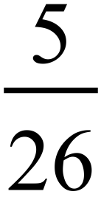 B. 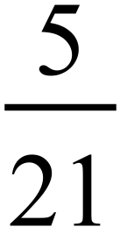 C. 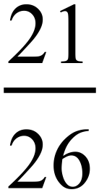 D. 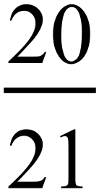
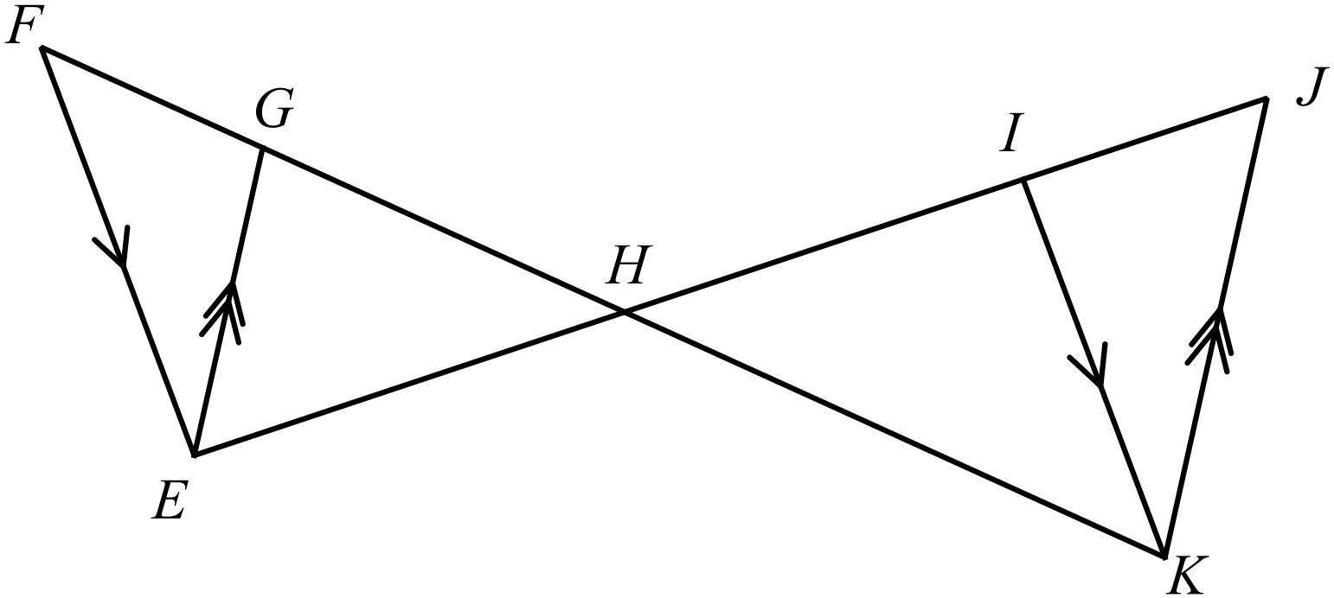In the diagram FE || IK and GE || JK.
Which pair of triangles are similar?

A.
B.
C.
D.
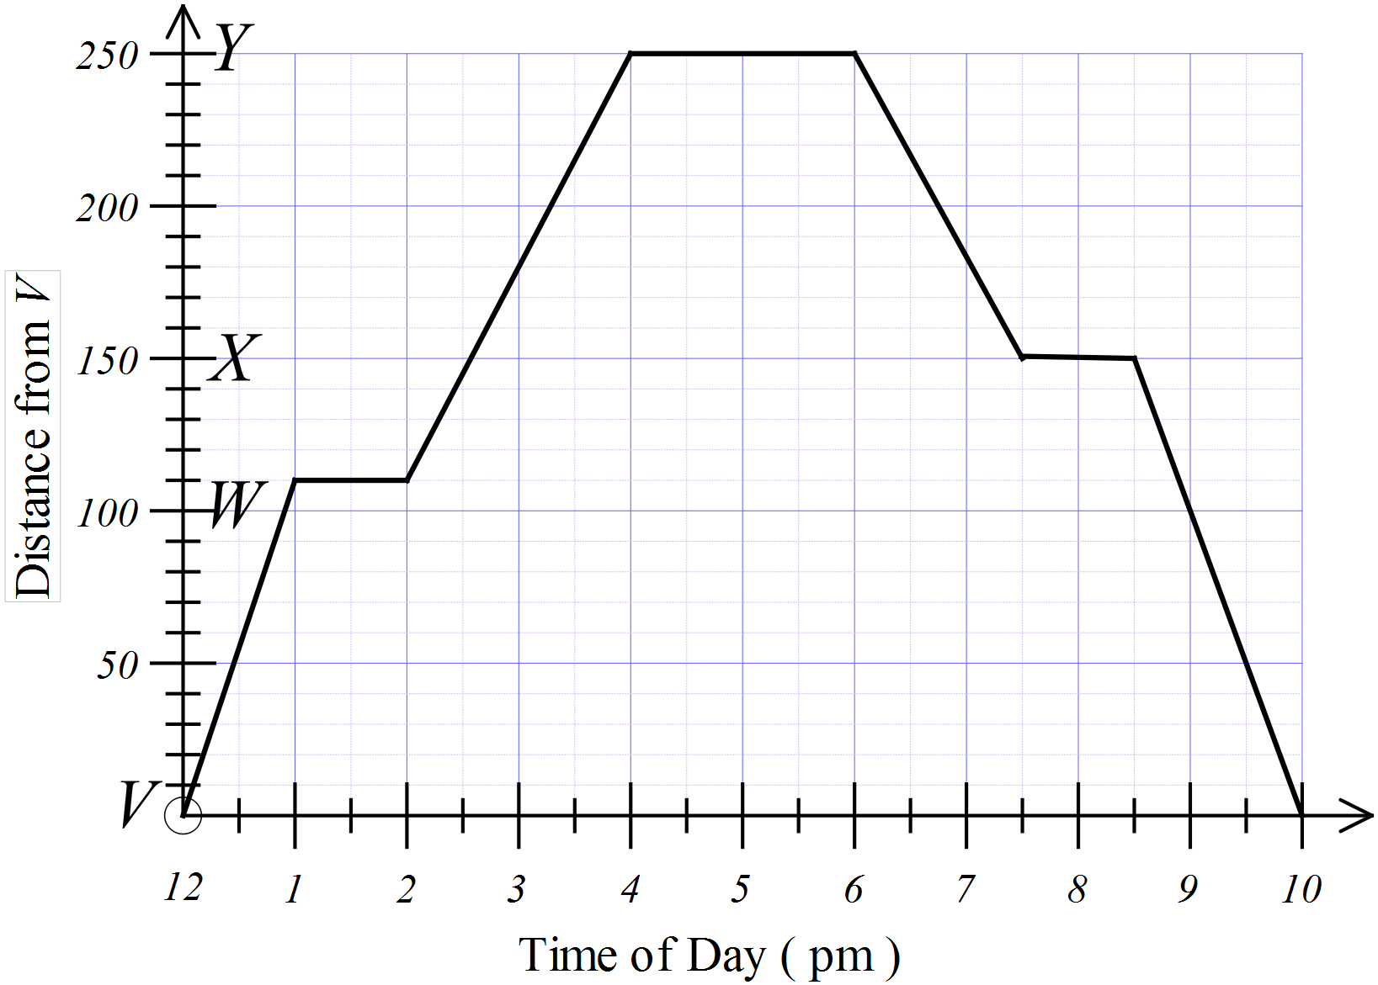The travel graph shows a journey from town V to town Y and back. Stops were also made at towns W and X which are between towns V and Y.
Town W is 110 km from town V.
What was the slowest average speed when travelling between the towns?
(Answer to the nearest km/h)
A. 50 km/h
B. 67 km/h
C. 70 km/h
D. 100 km/h

Which of the following are arranged in ascending order?

A. 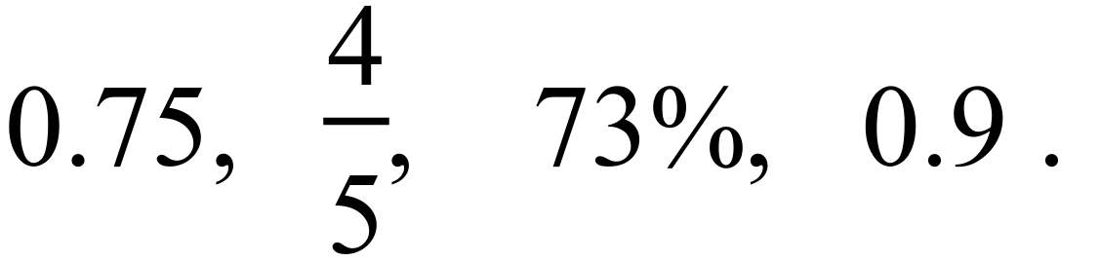
B. 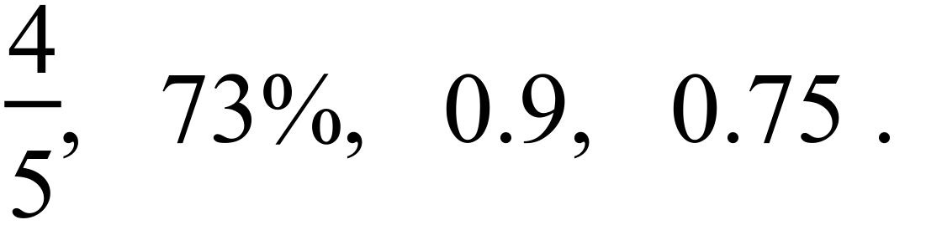
C. 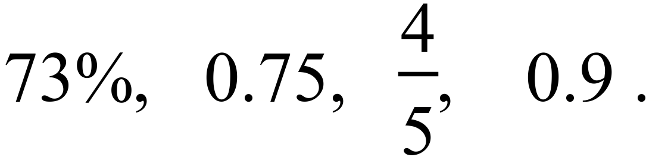
D. 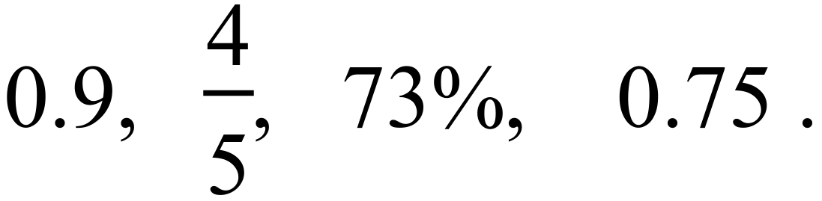
Socrates is paid a normal rate of $48 per hour for a 35 hour week, plus overtime at time and a half after that.
What would he earn for a 43 hour week?

A. $2064 B. $2256 C. $2775 D. $3096
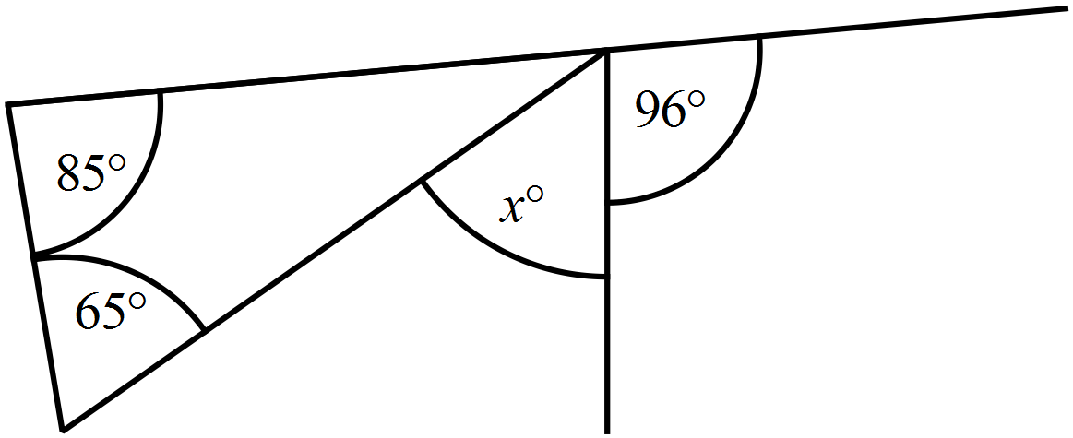What is the value of x?

A. 20º
B. 54º
C. 65º
D. 150º
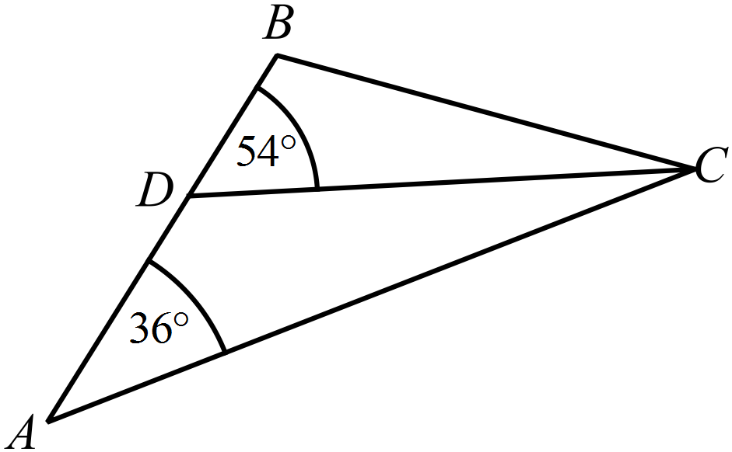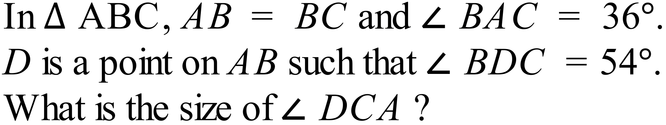

A. 18º
B. 20º
C. 36º
D. 72º
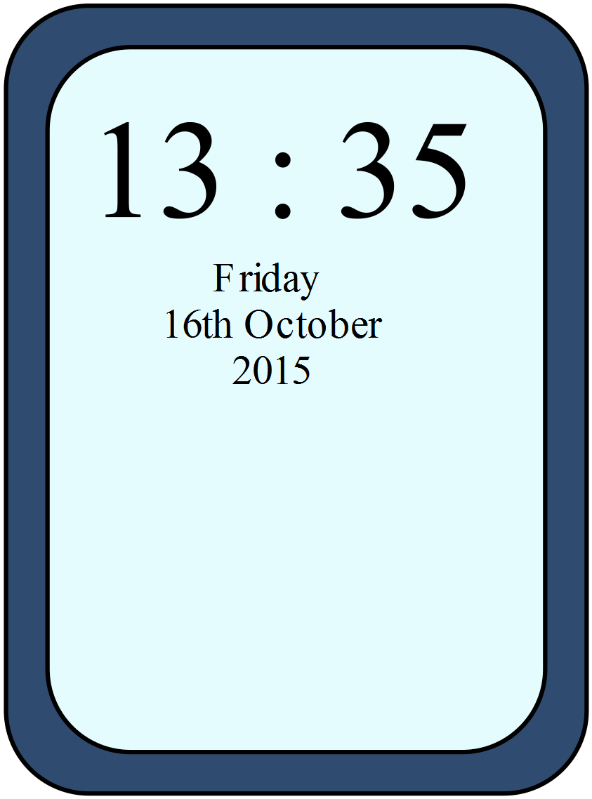Alan checks his phone and sees the time shown.
He has arranged to meet Fiona at a quarter past four that afternoon.
How long does he have till the meeting?

A. An hour and twenty minutes.
B. An hour and forty minutes.
C. Two hours and twenty minutes.
D. Two hours and forty minutes.
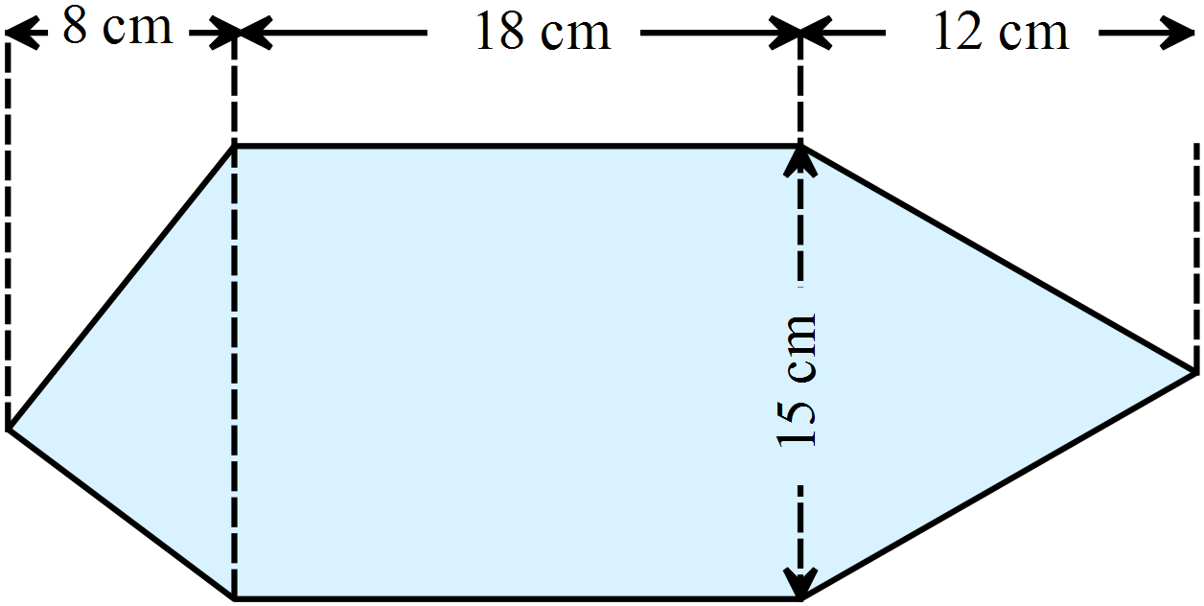What is the area of this shape?

A. 285 cm²
B. 320 cm²
C. 420 cm²
D. 510 cm²

Evaluate 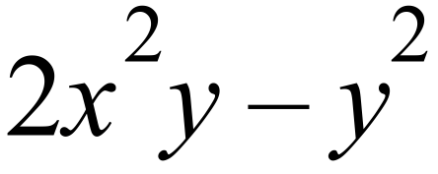 given 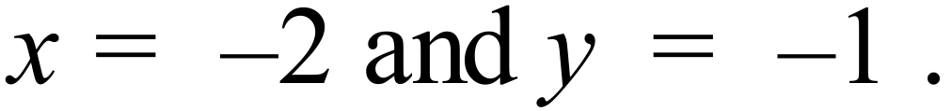

A. 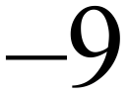 B. 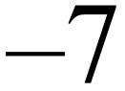 C. 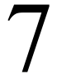 D. 9
Simplify 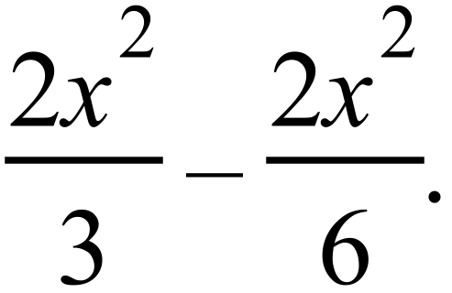

A. 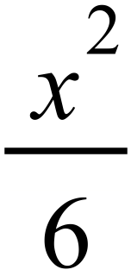 B. 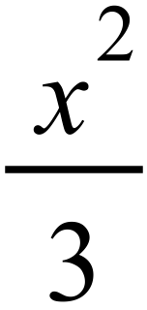 C. 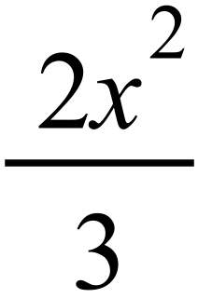 D. 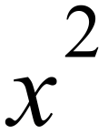
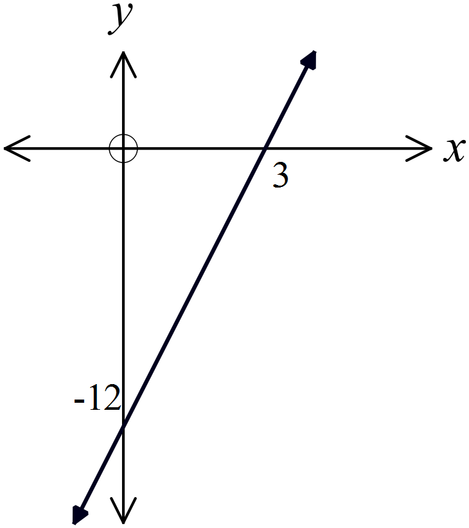What is the equation of this line?

A. 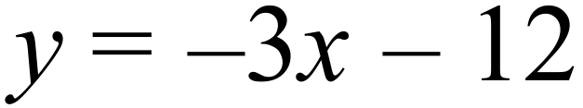
B. 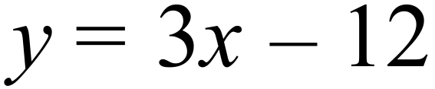
C. 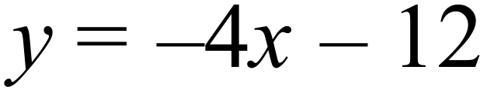
D. 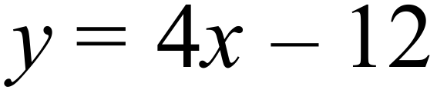

At its furthest, Pluto is 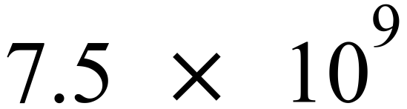 km from the Earth.
This can also be written as :
A. 75 000 000 km
B. 750 000 000 km
C. 7 500 000 000 km
D. 75 000 000 000 km
Which graph shows the solution to 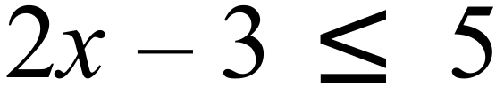 ?
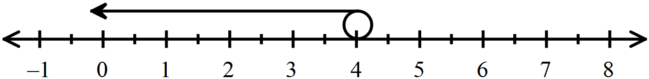
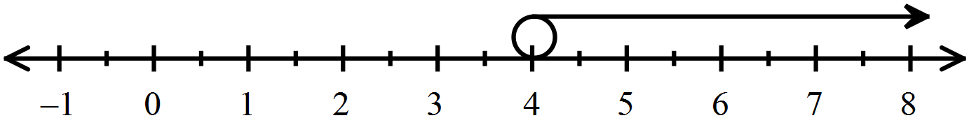 A.
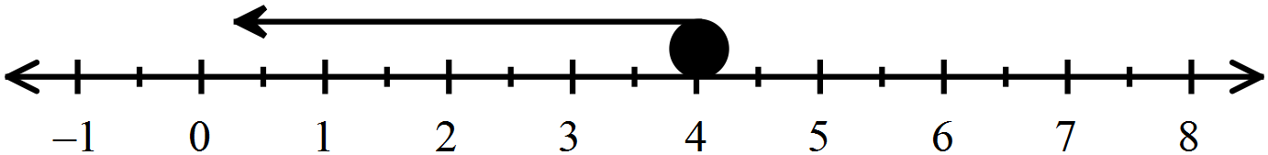 B.
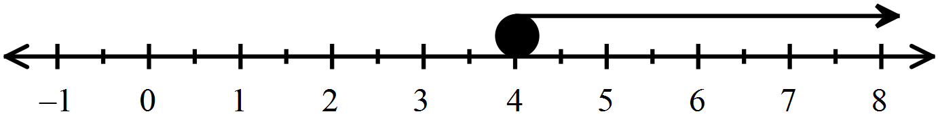 C.
D.

Questions 62 – 64 refer to the following.
The stem and leaf plot below shows the number of points scored by players in a single end of an outdoor archery tournament.

 | 2 | 2 | 8
 | 3 | 7 | 9
 | 4 | 5 | 7 | 8 | 8 | 8 | 8
 | 5 | 2 | 4 | 5 | 5 | 7 | 7 | 8 | 8 | 9
 | 6 | 0

What type of data is shown in the plot?

A. Categorical data.
B. Continuous numerical data.
C. Discrete numerical data.
D. Randomly generated data.
What is the interquartile range of the data?

A. 7 B. 11 C. 13 D. 38
If one score is chosen at random, what is the probability that it is less than 56?

A. 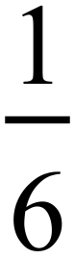 B. 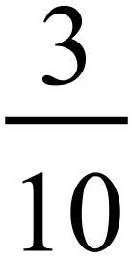 C. 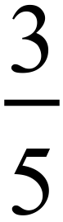 D. 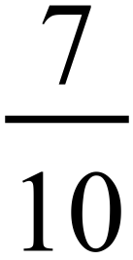
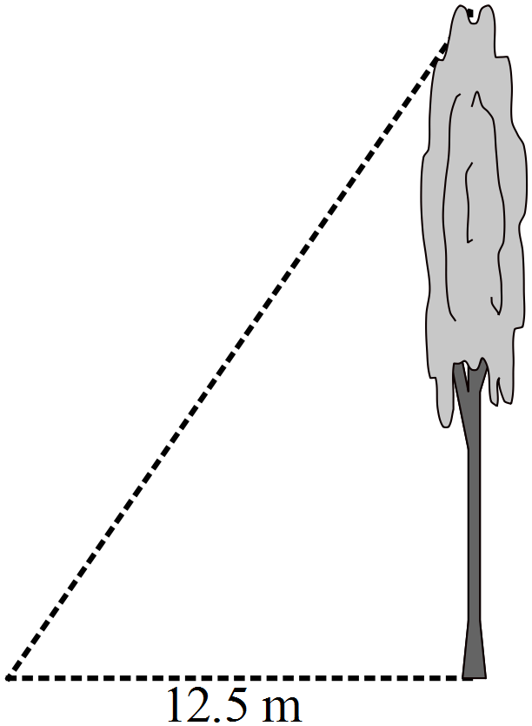From a point on level ground, 12.5 metres from the base of the tree, the angle of elevation of the top of the tree is 63º.
What is the height of the tree, to the nearest tenth of a metre?

A. 5.7 m
B. 6.4 m
C. 15.8 m
D. 24.5 m

Three towns A, B and C lie on the same flat plain.
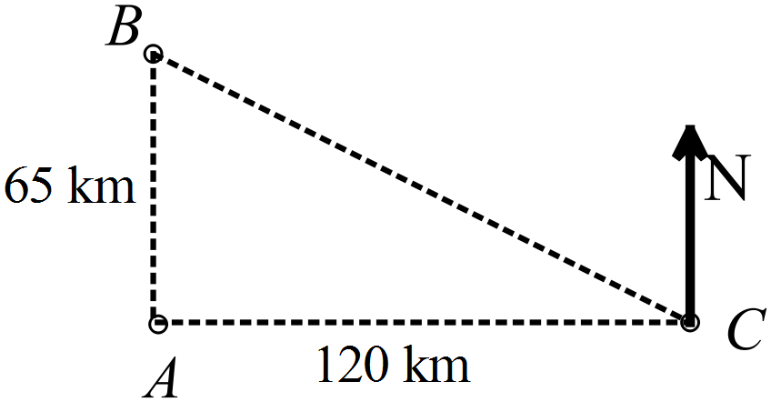A is 65 km due south of B.
C is 120 km due east of A.
What is the bearing of B from C?

A. 028º
B. 118º
C. 242º
D. 298º
Tim bought a set of tradesman’s tools for $3500 four years ago.
What is the value of the set now if it depreciated at 24% pa?

A. $1167.68 B. $1536.42 C. $2540.00 D. $2660.00

A jet ski can travel at 120 km/h in a straight line.
At this speed how long would it take to travel between two markers that are 900 m apart?

A. 27 seconds B. 30 seconds
C. 36 seconds D. 48 seconds


A model of the earth is made from polystyrene.
It is a sphere with a diameter of 2.4 metres.
What volume of polystyrene is needed?

A. 7.2 m³
B. 18.1 m³
C. 57.9 m³
D. 72.4 m³
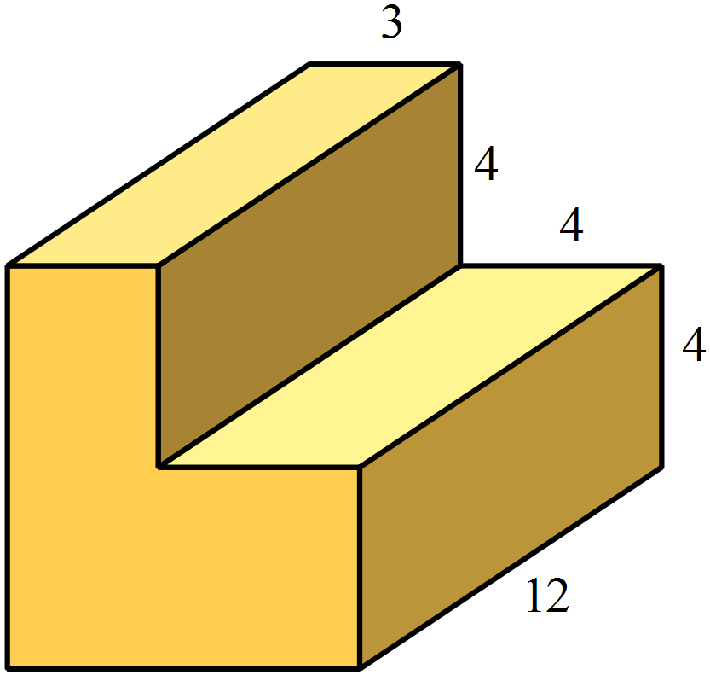In this prism, all angles are right angles and all measurements given are in cm.
What is the surface area of the prism?

A. 400 m²
B. 440 m²
C. 480 m²
D. 520 m²

The box plot shows the scores by contestant on a quiz.
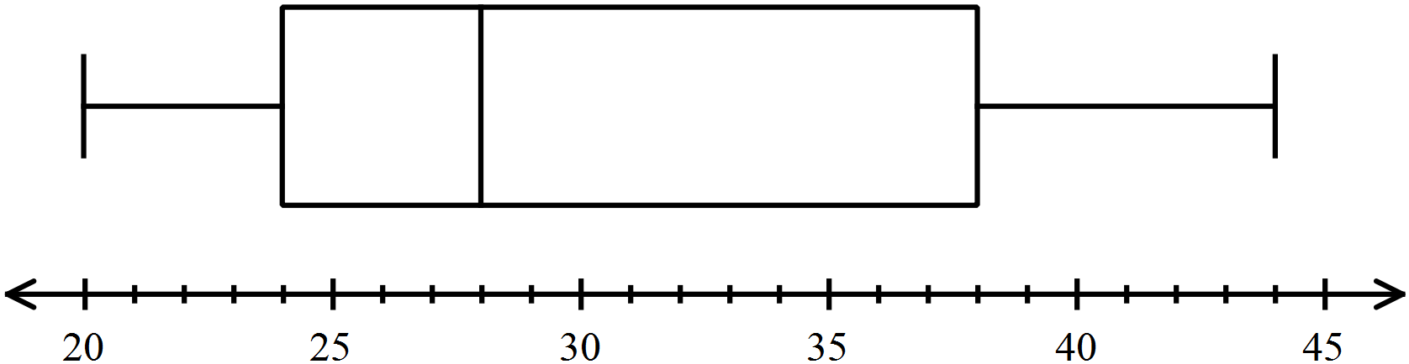

What percentage of the scores lie between 24 and 44?

A. 25% B. 50% C. 66% D. 75%
Which pair of lines are parallel?

A.
B.
C.
D. 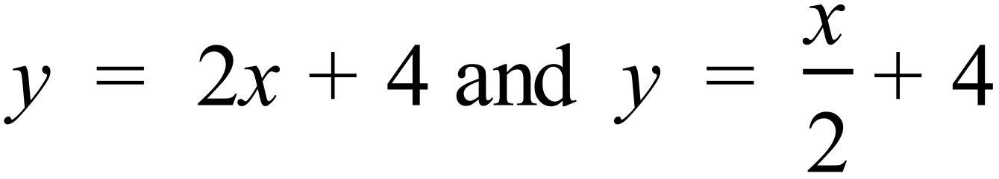
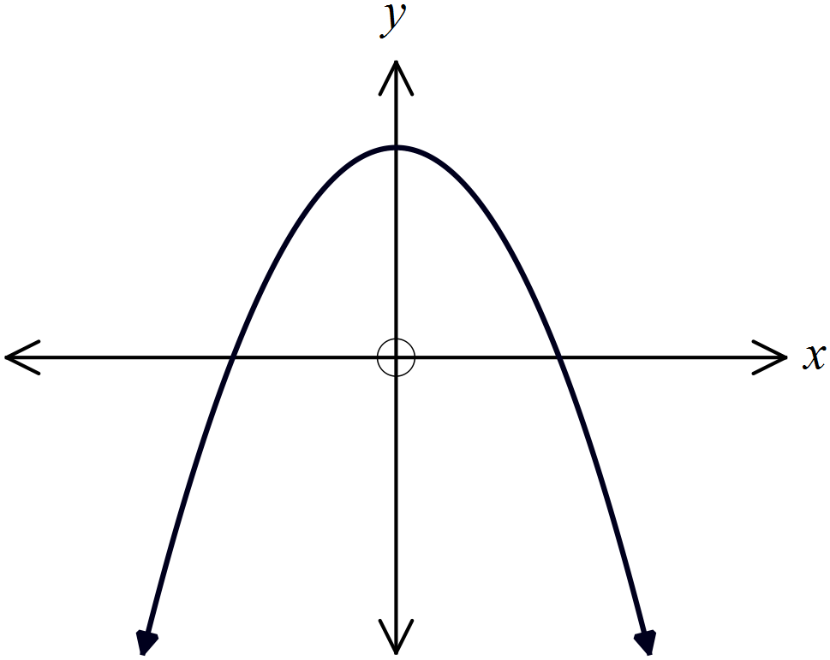Which of these equations could describe this graph?

A. 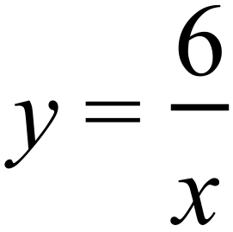
B. 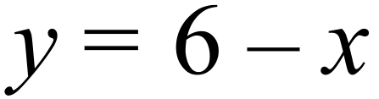
C. 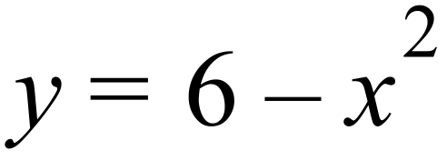
D. 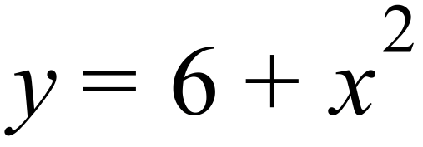

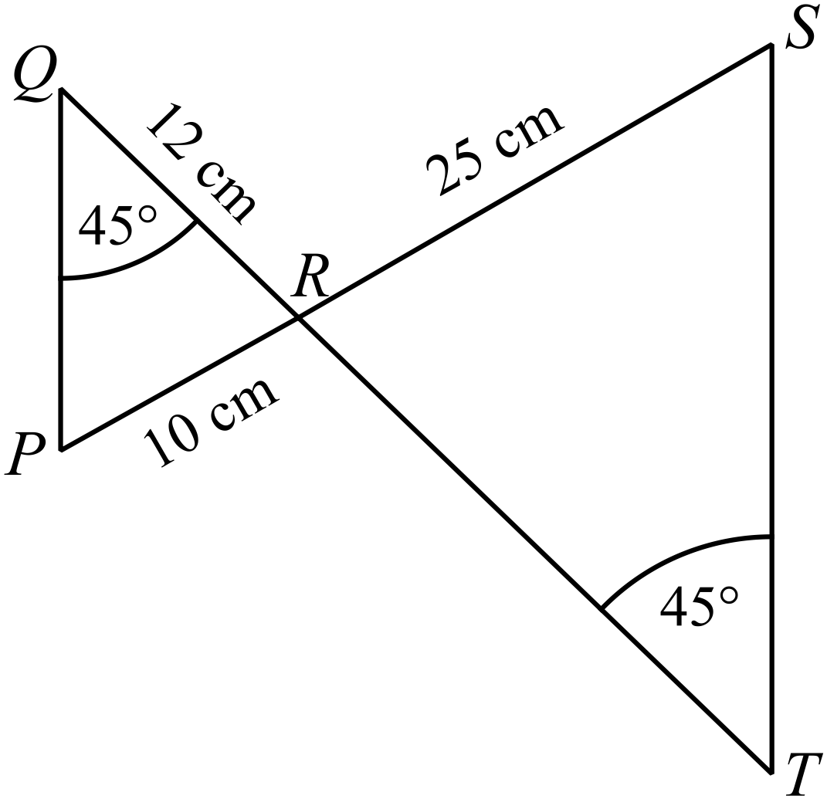In the diagram 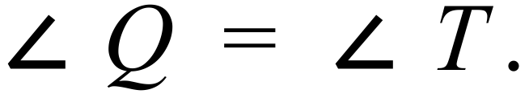
What is the length of TR (correct to 1 d.p.)?

A. 20.8 cm
B. 30.0 cm
C. 48.0 cm
D. 60.0 cm

Which of these scatterplots indicates a strong positive relationship between two variables?

A. B.
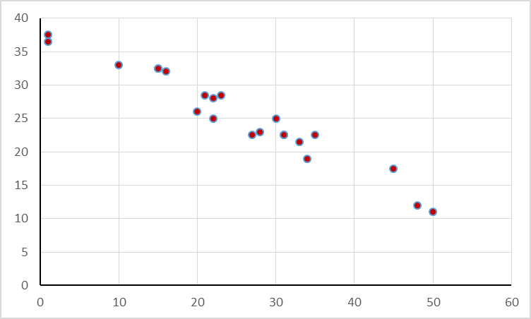
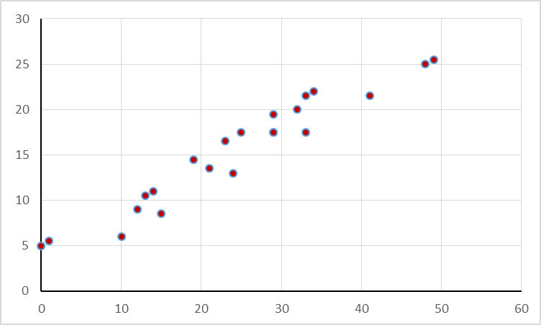

C. D.
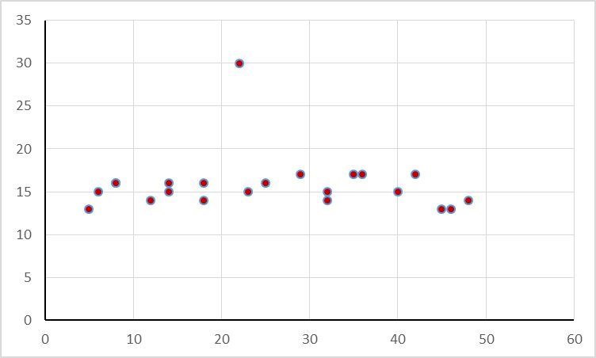
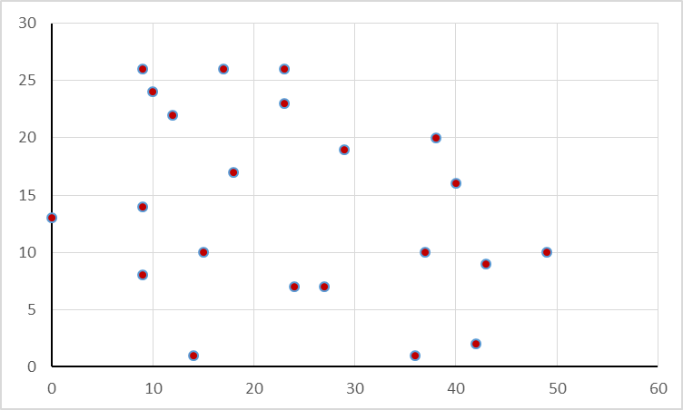

End of Section 1

School Name  Yearly Examination  Year 10 |  | Mathematics Course  2015
Section 2  Part B  Longer Answer Section |  | Name : _______________________________
 |  | Class/Teacher___________________________
Write all working and answers in the spaces provided on this examination paper.
Calculators are allowed for this section.

 |  | Marks
76. | Elizabeth is a novelist and she recorded the number pages she wrote each day over a period of a month. The results are shown in the frequency table below.
  Number of pages  x | Frequency  f | fx | Cumulative frequency.
  2 | 9 | 18 | 9
  3 | 10 | 30 | 19
  4 | 5 | 20 | 24
  5 | 3 | 15 | 27
  6 | 2 | 12 | 29
  7 | 1 | 7 | 30
   | 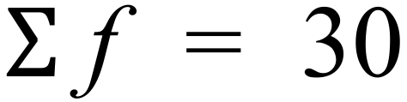 | 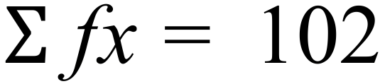
 | - Describe the shape of the distribution.  ……………………………………………………………………………………………....  ………………………………………………………………………………………………. | 1
 | - What is the mean number of pages that she wrote?  ……………………………………………………………………………………………....  ………………………………………………………………………………………………. | 1
 | - What is the median number of pages that she wrote?  ………………………………………………………………………………………………. | 1
 | - What is the interquartile range of the data?  ……………………………………………………………………………………………....  ………………………………………………………………………………………………. | 1
77. | A cylindrical water tank has the dimensions shown.  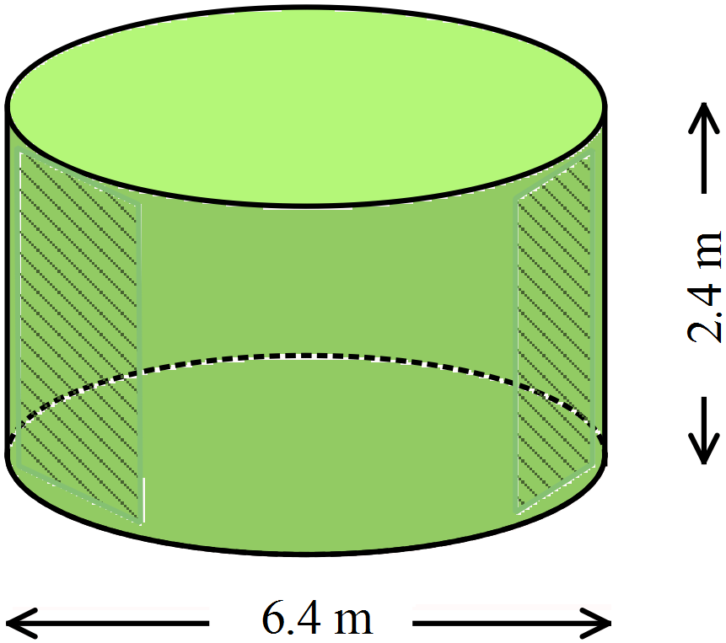
 | - What volume of water would the tank hold?  ……………………………………………………………………………………………....  ………………………………………………………………………………………………. | 1
 | - The tank is to be made from plastic which has a constant thickness.  One square metre of the plastic has a mass of 7.5 kg.  What would be the mass of the empty plastic tank?  ……………………………………………………………………………………………....  ……………………………………………………………………………………………....  ………………………………………………………………………………………………. | 2
78. | - Solve the equation below, showing your reasoning and calculations.  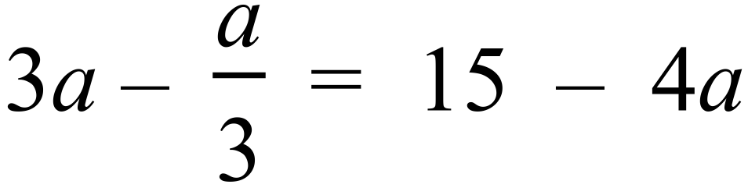  ……………………………………………………………………………………………....  ……………………………………………………………………………………………….  ……………………………………………………………………………………………….  ………………………………………………………………………………………………. | 2
 | - Use the formula 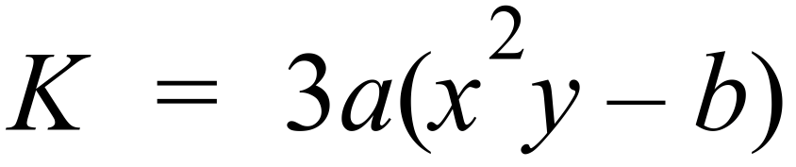 to find the value of y, when  ……………………………………………………………………………………………....  ……………………………………………………………………………………………….  ……………………………………………………………………………………………….  ………………………………………………………………………………………………. | 2
79. | Aiden deposits $16 500 into an account which pays interest at 7.2% p.a. compounding quarterly.
 | - How much would the investment be worth after 4 years?  ……………………………………………………………………………………………....  ……………………………………………………………………………………………….  ………………………………………………………………………………………………. | 1
 | - Another account pays the same interest rate, but it is compounded monthly.  How much more would Aiden earn if he deposited his money in the 2nd account?  ……………………………………………………………………………………………....  ……………………………………………………………………………………………….  ………………………………………………………………………………………………. | 1
80. | In the diagram, ED || BC, AE = 10 cm, ED = 4 cm and BC = 30 cm.  Calculate the length of EB.  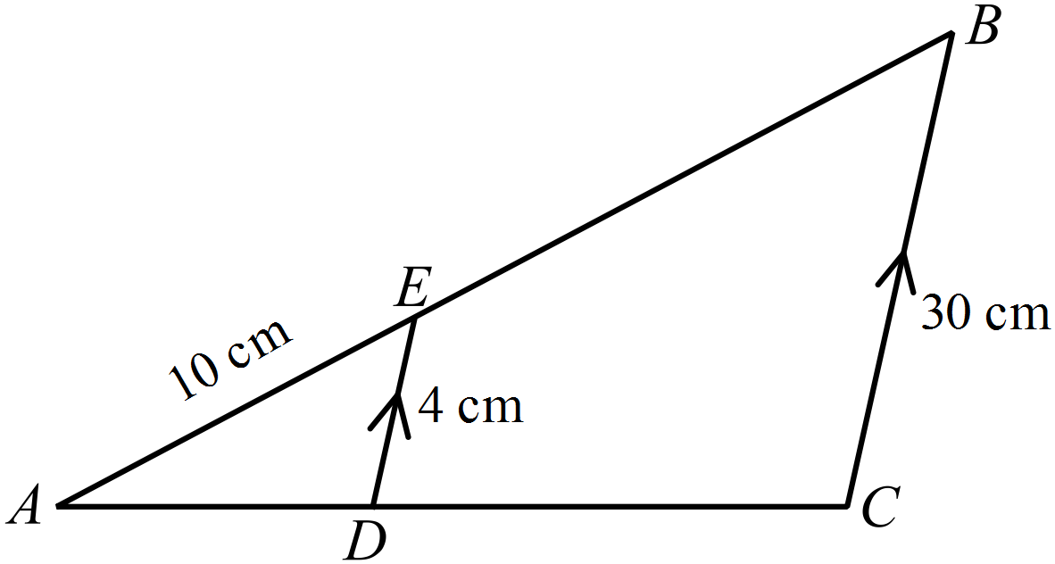  ……………………………………………………………………………………………....  ……………………………………………………………………………………………....  ……………………………………………………………………………………………....  ………………………………………………………………………………………………. | 2
81. | - Cain has climbed to the peak of Mount Eden which is 4560 m above sea level.  He measures the angle of elevation of the peak of Mt Nod to be 24º.  Using his GPS he finds that Mt Nod is 1.8 km due east of Mt Eden.  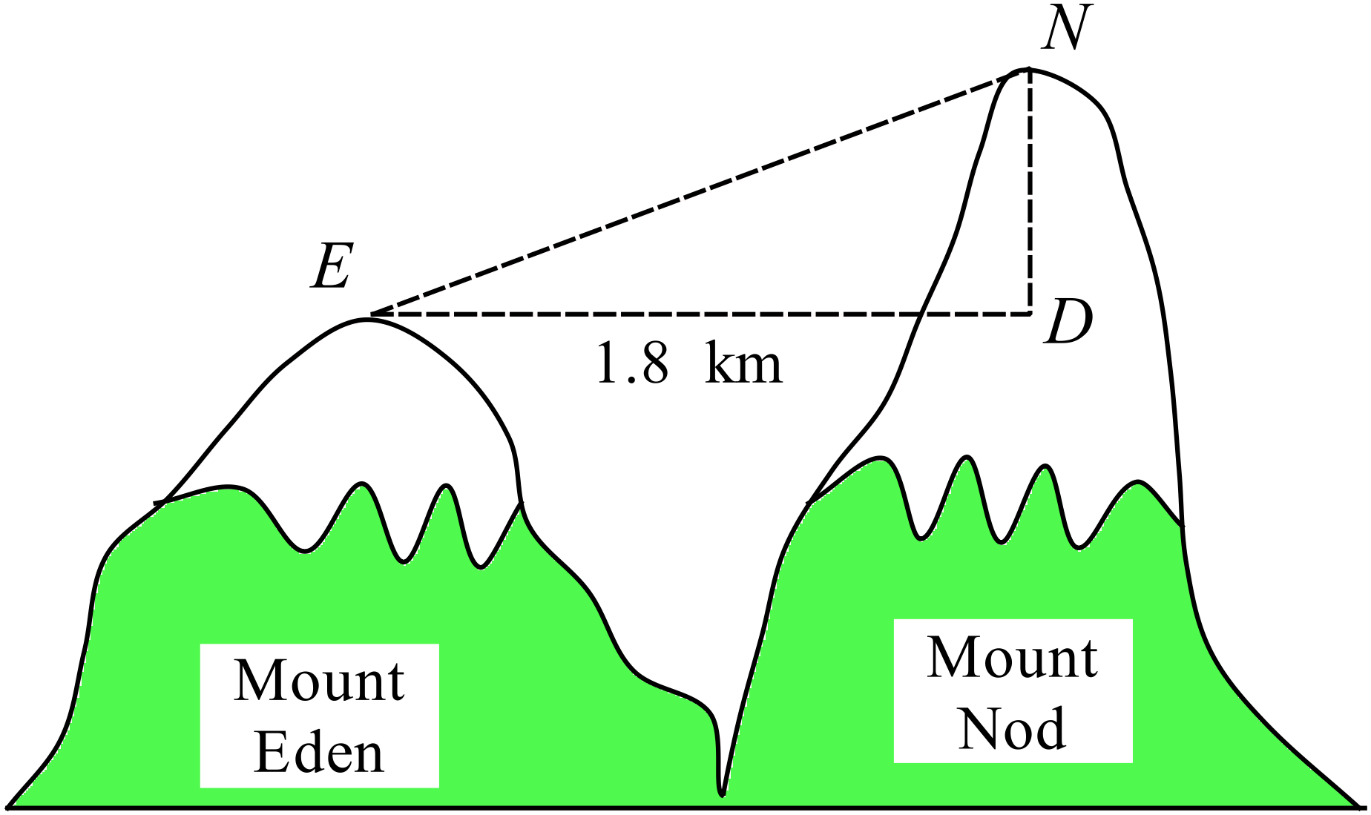  How far above sea level is the peak of Mt Nod?  ……………………………………………………………………………………………....  ……………………………………………………………………………………………....  ……………………………………………………………………………………………....  ………………………………………………………………………………………………. | 2
 | - 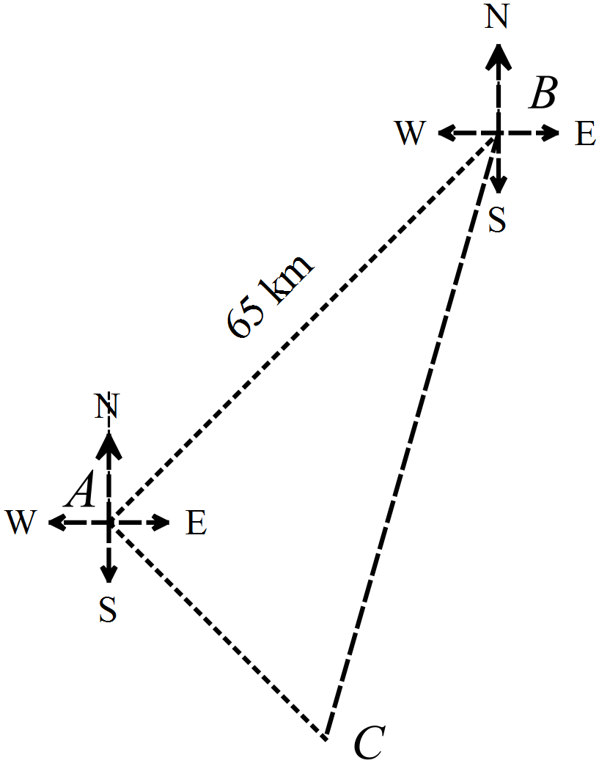Three towns are located on a wide flat plain.  Blackville (B) is 65 km NE of Amityville (A).  Clarkesville (C) is SE of Amityville  Clarkesville is on a bearing of 190º from Blackville.  How far is Clarkesville from Blackville?  ……………………………………………………………………………………………....  ……………………………………………………………………………………………....  ……………………………………………………………………………………………....  ………………………………………………………………………………………………. | 2
82. | The points P (-4, , 2), Q (4, 6) and R (-1, -4) are shown on the number plane below.  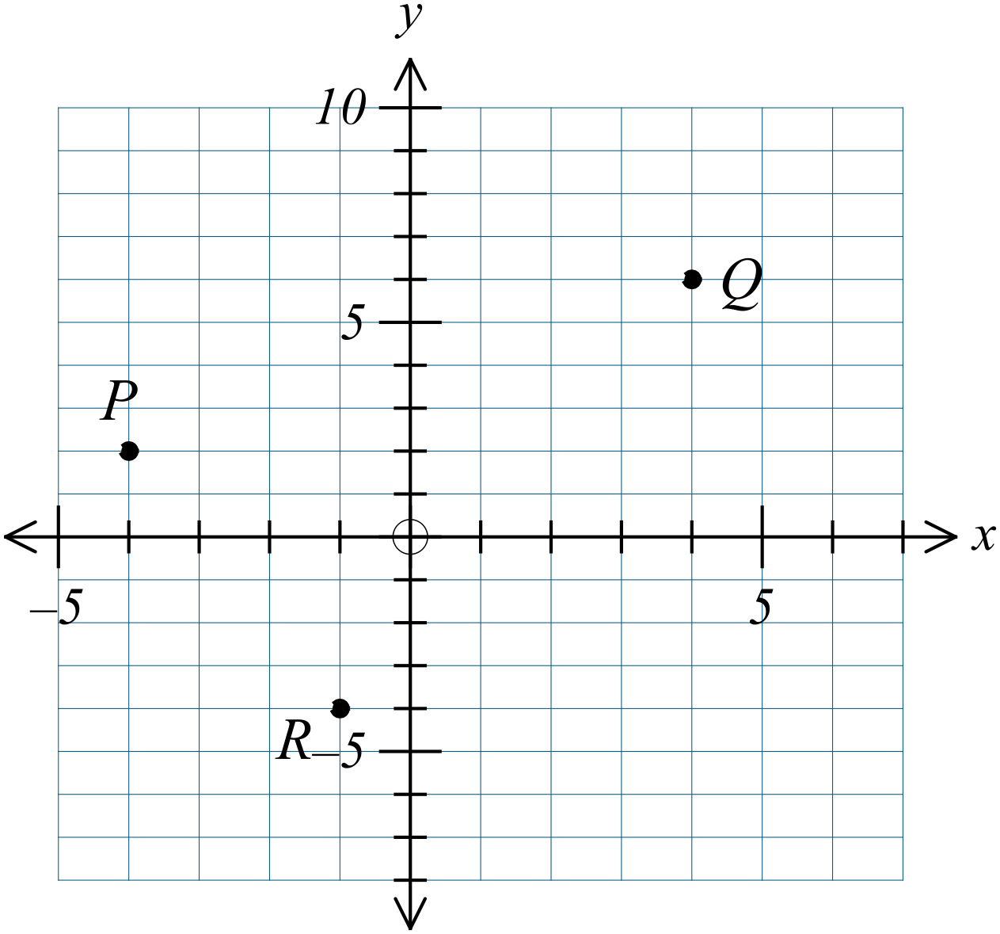
 | - What is the midpoint of PQ?  ……………………………………………………………………………………………....  ………………………………………………………………………………………………. | 1
 | - What is the distance QR? (Leave your answer as a surd.)  ……………………………………………………………………………………………....  ……………………………………………………………………………………………....  ………………………………………………………………………………………………. | 1
 | - What is the gradient of PR?  ……………………………………………………………………………………………....  ……………………………………………………………………………………………....  ………………………………………………………………………………………………. | 1
 | - What is the equation of the line PR?  ……………………………………………………………………………………………....  ……………………………………………………………………………………………....  ………………………………………………………………………………………………. | 1
83. | In the diagram below, KN = NL,  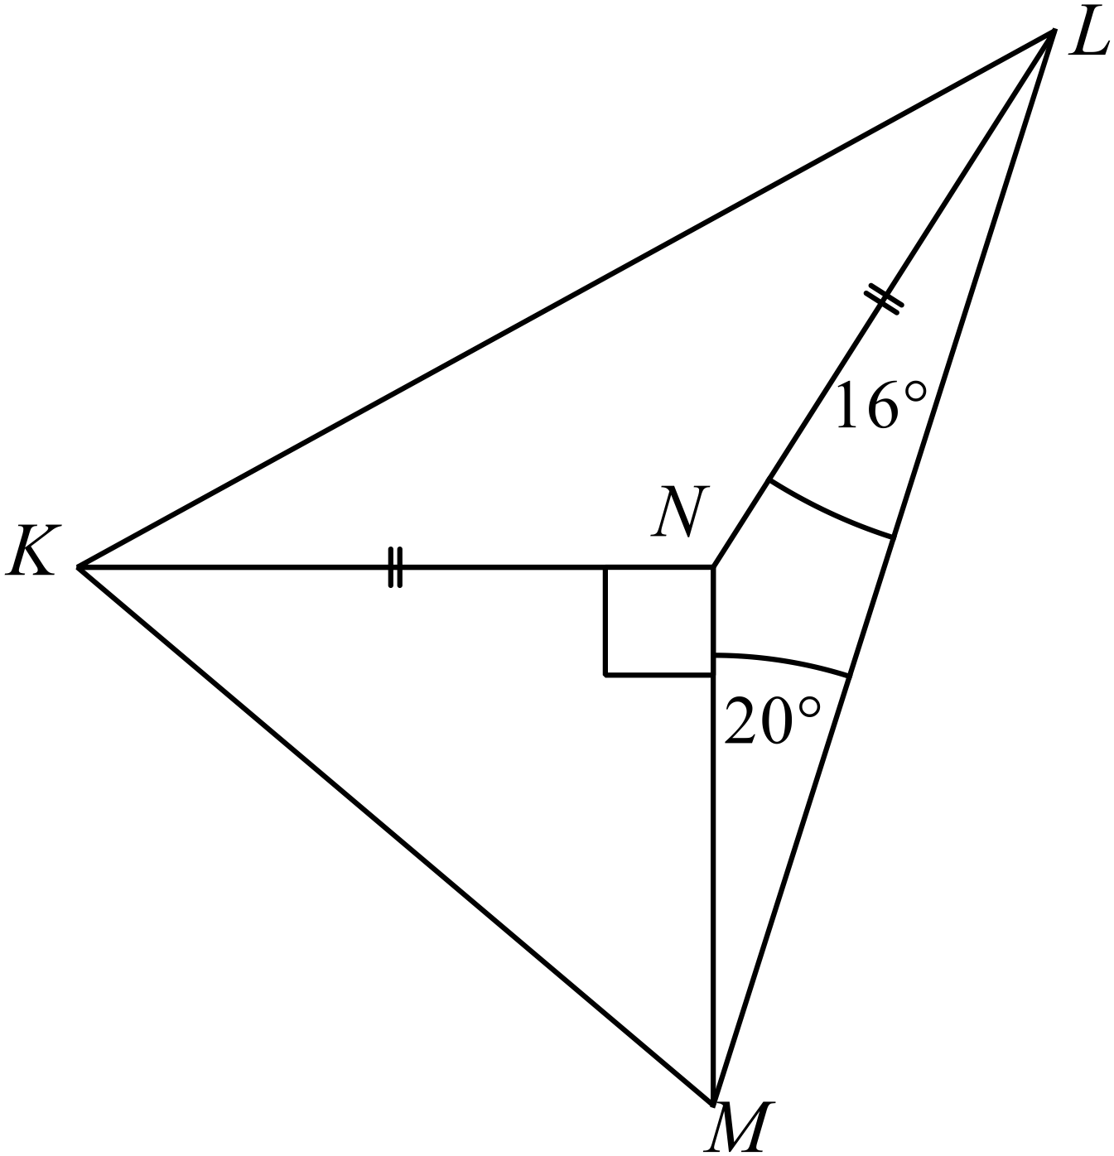.
 | - Find the size of 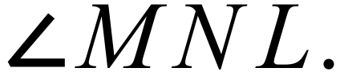  ……………………………………………………………………………………………....  ………………………………………………………………………………………………. | 1
 | - Find the size of 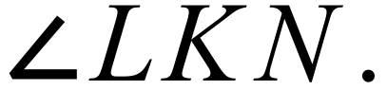  ……………………………………………………………………………………………....  ………………………………………………………………………………………………. | 1
 | End of Examination.

School Name
Year 10 Yearly Examination
Mathematics Course 2015
Multiple Choice Section Answer Sheet
Name ________________________________ Teacher ________________________

Completely fill the response oval representing the most correct answer.
Use a black or blue pen or 2B pencil.

26. A B C D
27. A B C D
28. A B C D
29. A B C D
30. A B C D
31. A B C D
32. A B C D
33. A B C D
34. A B C D
35. A B C D
36. A B C D
37. A B C D
38. A B C D
39. A B C D
40. A B C D
41. A B C D
42. A B C D
43. A B C D
44. A B C D
45. A B C D
46. A B C D
47. A B C D
48. A B C D
49. A B C D
50. A B C D

51. A B C D
52. A B C D
53. A B C D
54. A B C D
55. A B C D
56. A B C D
57. A B C D
58. A B C D
59. A B C D
60. A B C D
61. A B C D
62. A B C D
63. A B C D
64. A B C D
65. A B C D
66. A B C D
67. A B C D
68. A B C D
69. A B C D
70. A B C D
71. A B C D
72. A B C D
73. A B C D
74. A B C D
75. A B C D

